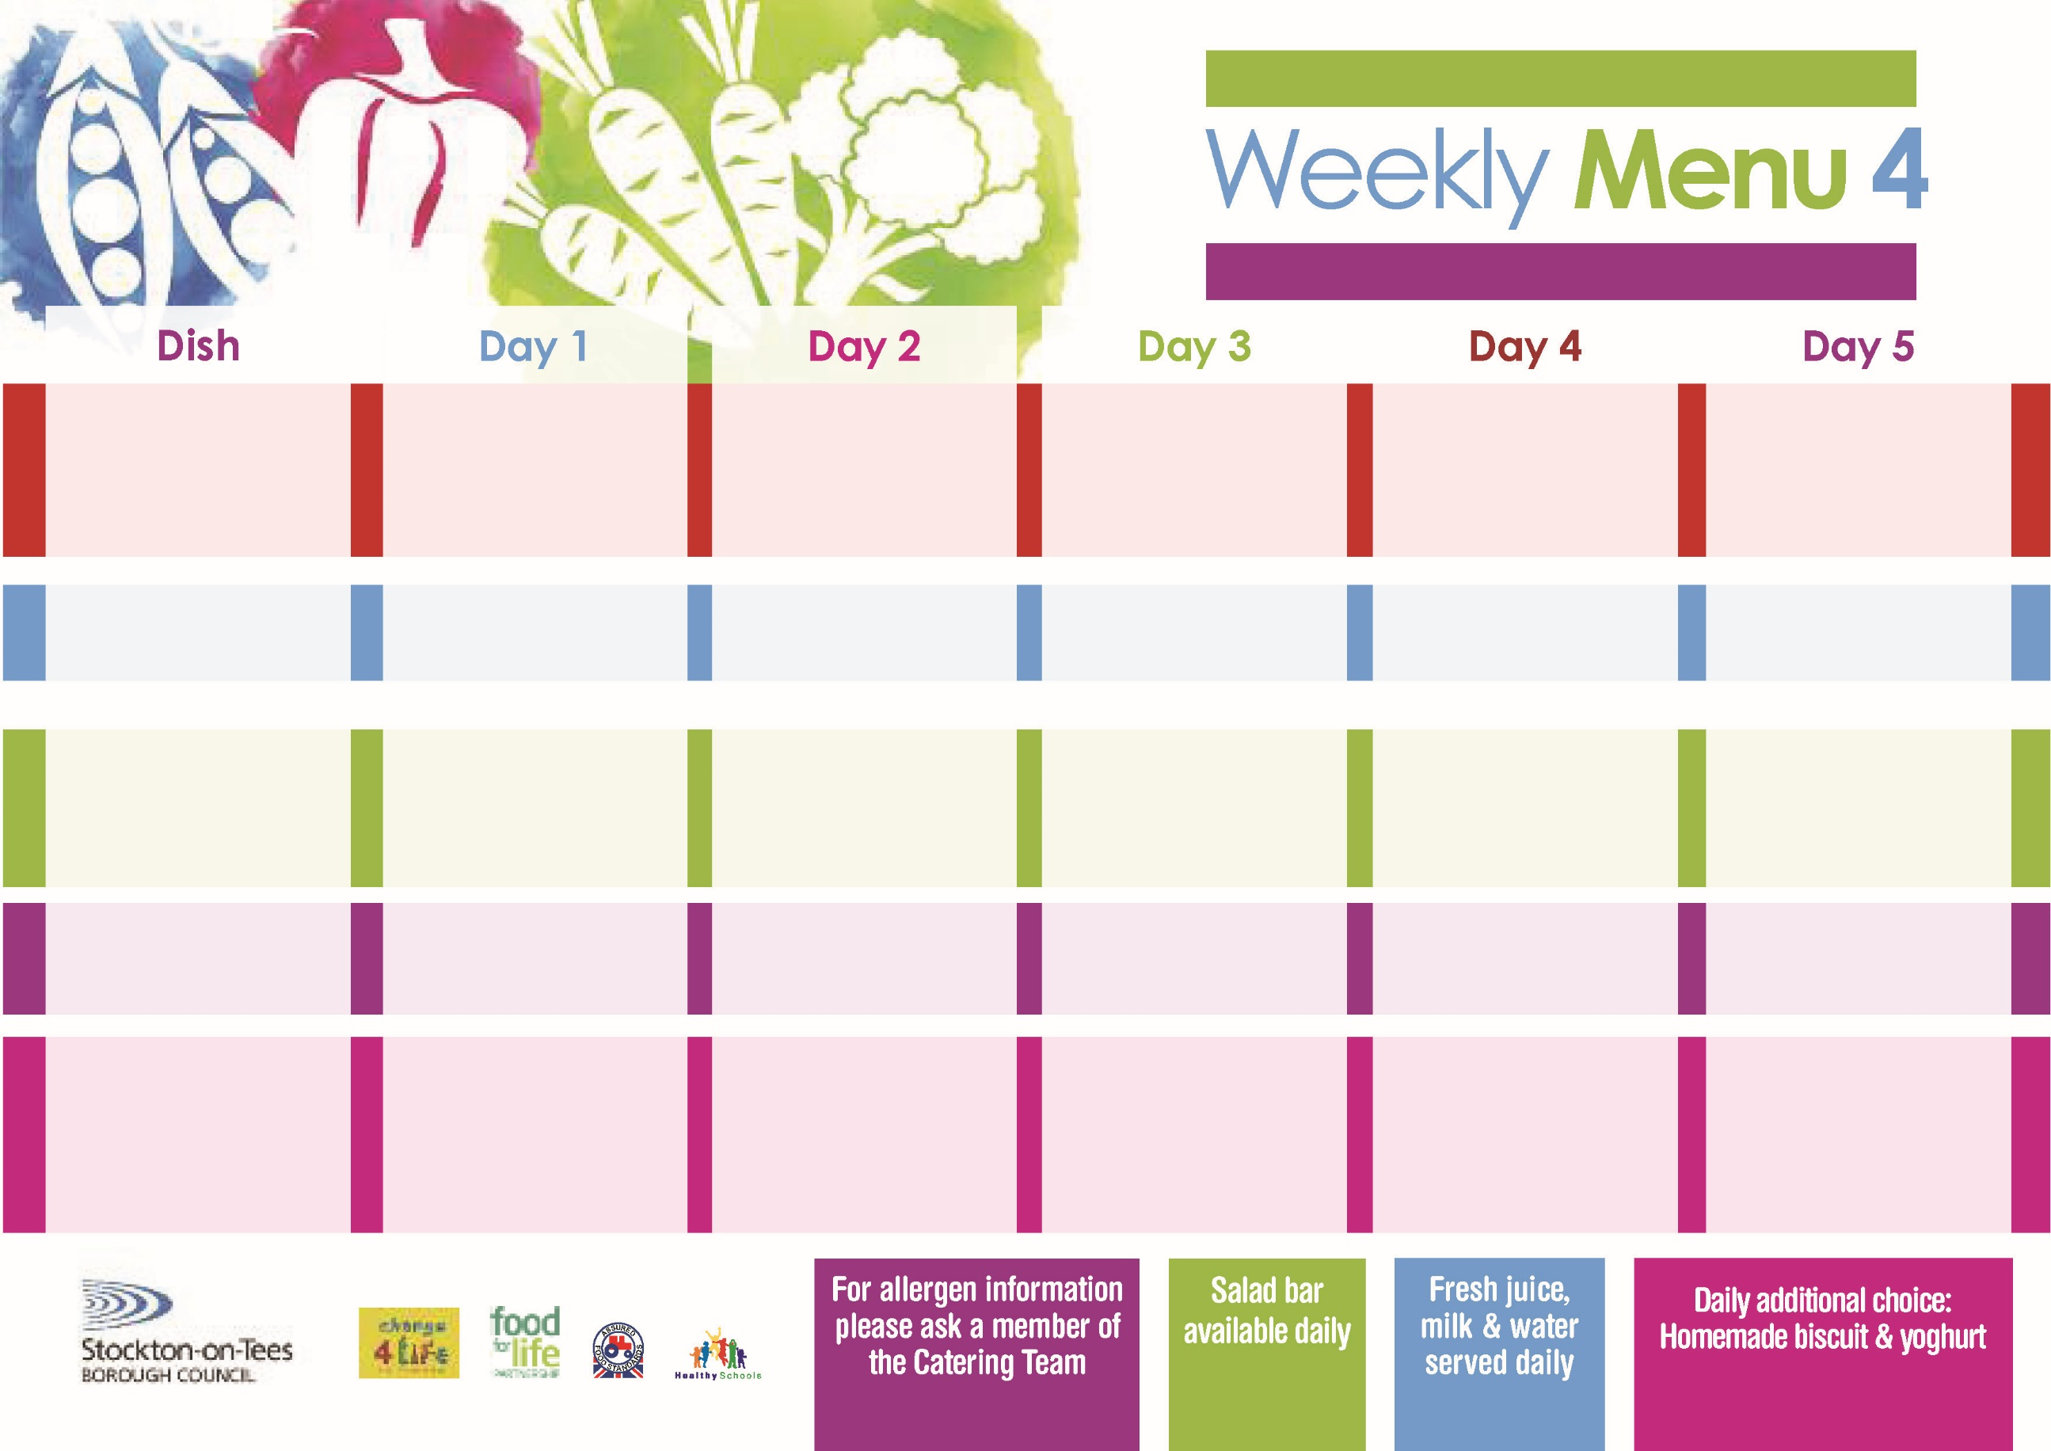

**Fish Goujons**

**Oven Baked Chips**

**Garden Peas**

**Baked Beans**

**Sausage Roll**

**Oven Baked Chips**

**Garden Peas**

**Baked Beans**

**Cheese Sandwich (V)**

**Oven Baked Chips**

**Orange Sponge**

**with Custard Sauce**

**Cold Bar**

**Fresh Fruit Kebab**

**Chicken Pie**

**Creamed Potatoes**

**Mixed Vegetables**

**Green Beans**

**Cheese & Tomato Pizza (V)**

**Baked Potato Wedges**

**Spaghetti Hoops**

**Tuna Sandwich**

**Baked Potato Wedges**

**Rice Pudding**

**with Sultanas**

**Cold Bar**

**Fresh Fruit Bowl**

**Beef Burger in a Bun**

**Oven Roasted Potatoes**

**Baked Beans**

**Sweetcorn**

**Quorn Burger in a Bun (V)**

**Homemade Quiche (V)**

**Oven Roasted Potatoes**

**Baked Beans**

**Sweetcorn**

**Egg Mayonnaise Sandwich** **(V)**

**Oven Roasted Potatoes**

**Jam Roly Poly**

**with Custard Sauce**

**Cold Bar**

**Watermelon Slices**

**16th May, 20th June & 18th July, 2022**

**Mince & Suet Crust**

**Baby Boiled Potatoes**

**Cabbage**

**Diced Carrots**

**Cheese & Tomato**

**Pasta Bake (V)**

**Homemade Herby Bread**

**Tossed Salad**

**Tuna Sandwich**

**Baby Boiled Potatoes**

**Eve’s Pudding**

**with Custard Sauce**

**Cold Bar**

**Fresh Fruit Salad**

**Toad in the Hole**

**Creamed Potatoes**

**Broccoli**

**Diced Swede**

**Quorn Toad in the Hole (V)**

**Fish Fillet Fingers**

**Oven Baked Jacket Potato**

**Spaghetti Hoops**

**Cheese Sandwich (V)**

**Oven Baked Jacket Potato**

**Marble Sponge**

**with Custard Sauce**

**Cold Bar**

**Melon Boat**

**Red Choice**

**Blue Choice**

**Green Choice**

**Cold Selection**

**Desserts**

**Wristband School Menu**