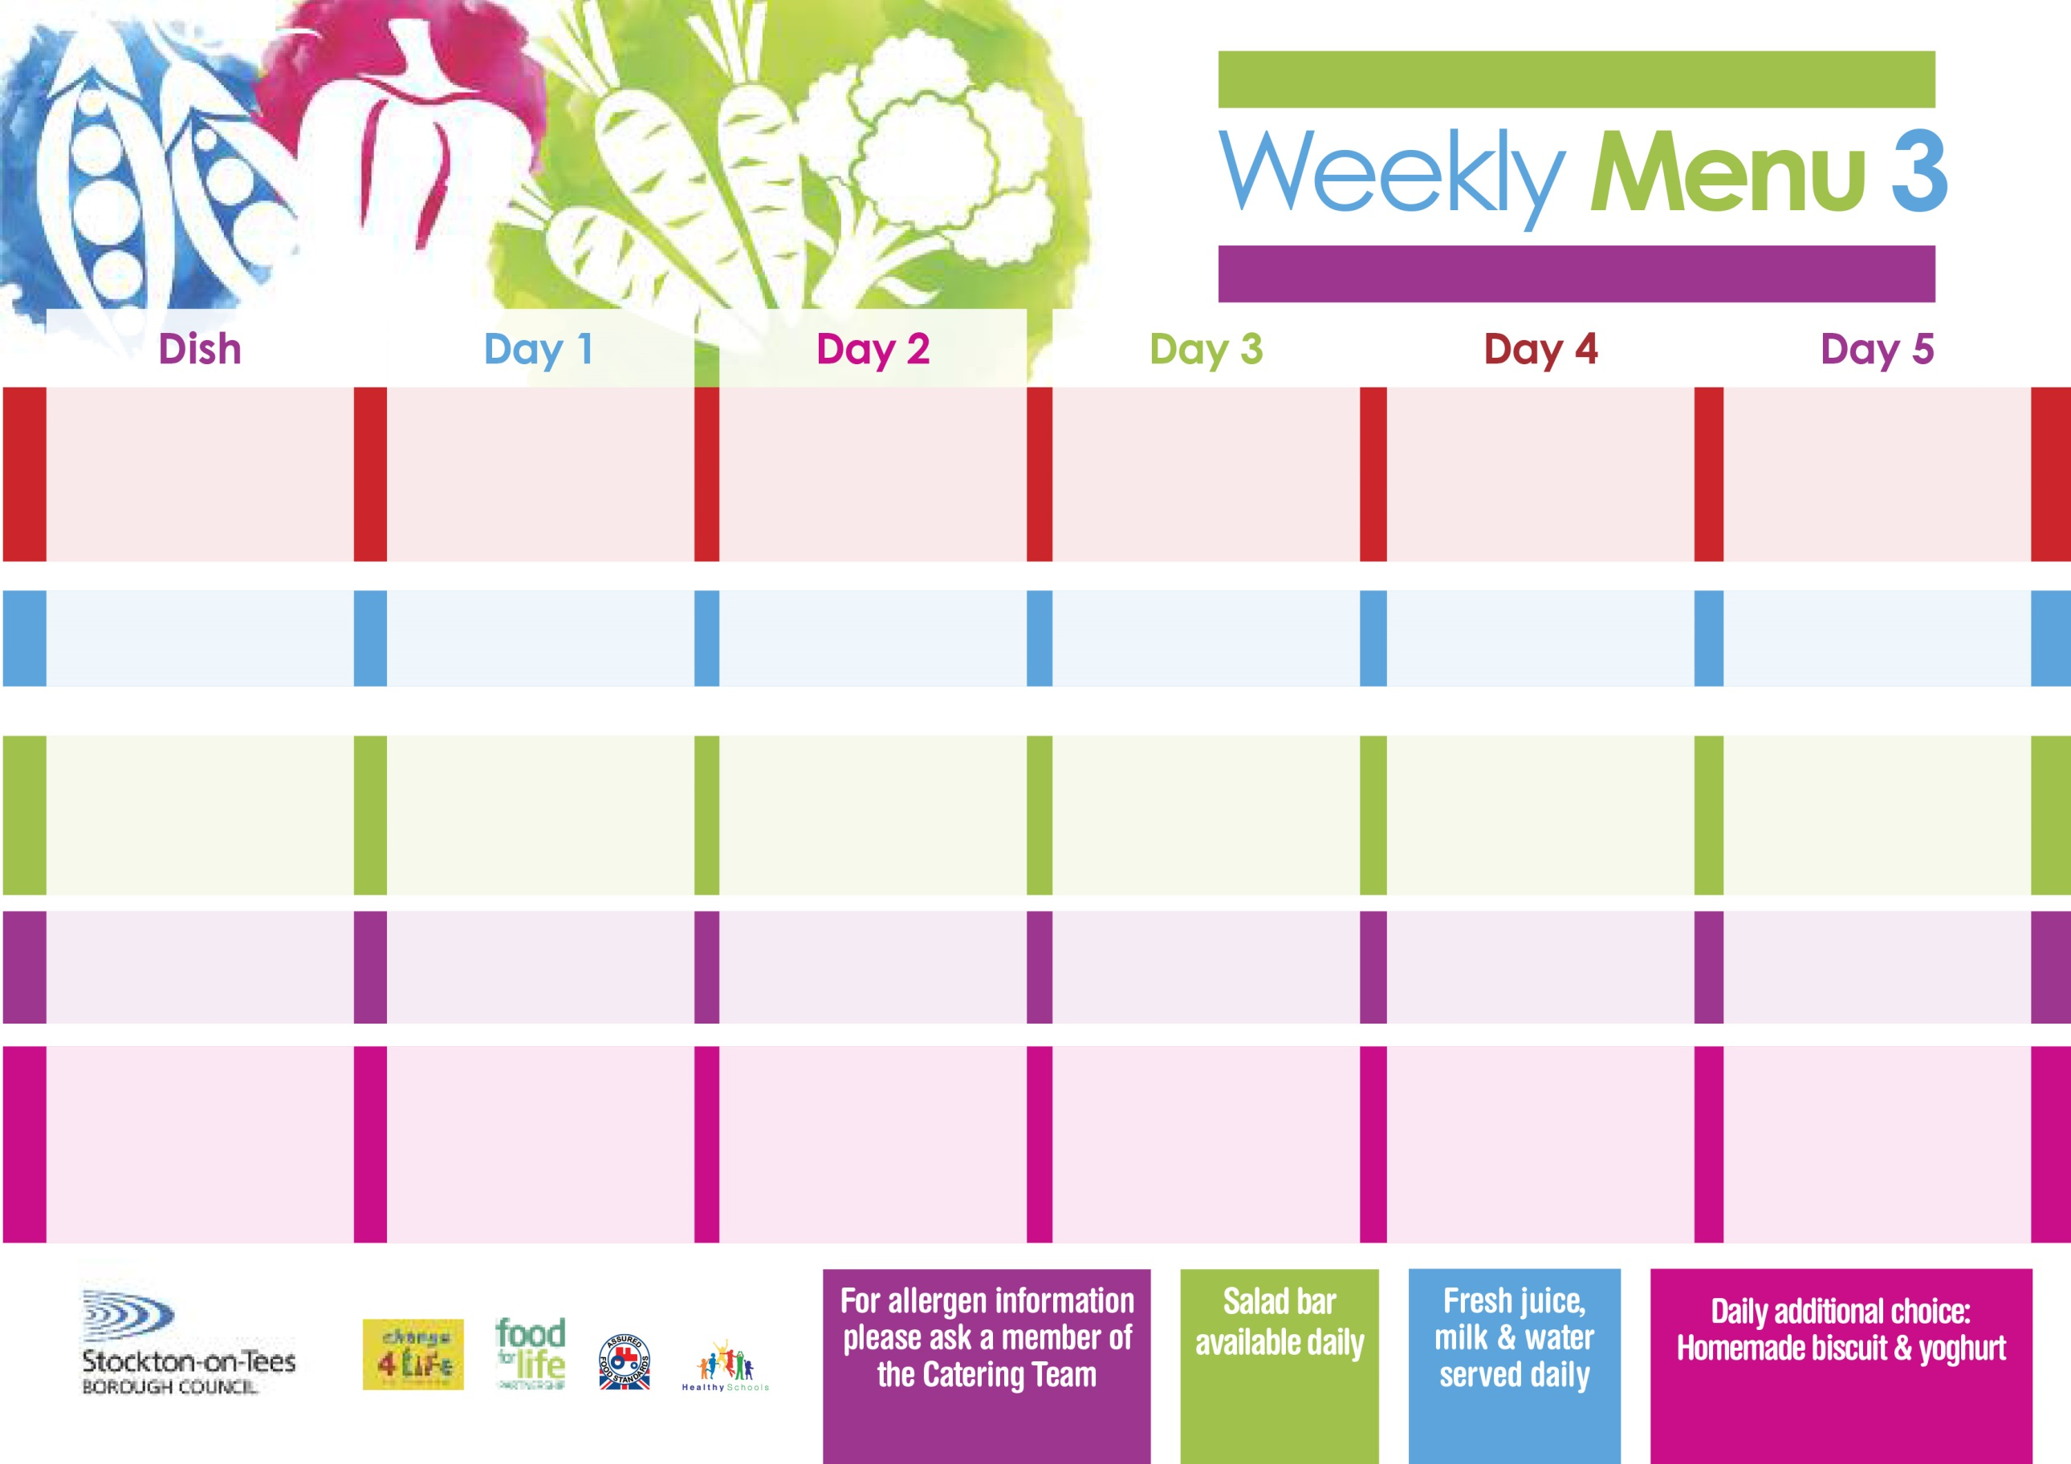

**9th May, 13th June & 11th July, 2022**

**Harry Ramsden Fish Fillet**

**Oven Baked Chips**

**Garden Peas**

**Baked Beans**

**Pizza Whirls (V)**

**Oven Baked Chips**

**Garden Peas**

**Baked Beans**

**Egg Mayonnaise Sandwich (V)**

**Oven Baked Chips**

**Jam Sponge**

**with Custard Sauce**

**Cold Bar**

**Fresh Fruit Platter**

**Pork Casserole & Leek Dumplings**

**Creamed Potatoes**

**Mixed Vegetables**

**Broccoli**

**Fish Cake**

**Baked Jacket Potatoes**

**Baked Beans**

**Ham Sandwich**

**Baked Jacket Potato**

**Choc Chip Sponge**

**with Custard Sauce**

**Cold Bar**

**Fresh Fruit Bowl**

**Chicken Curry**

**with Rice**

**Sweetcorn**

**Loaded Pizza (V)**

**Baked Potato Wedges**

**Spaghetti Hoops**

**Sweetcorn**

**Egg Sandwich (V)**

**Baked Potato Wedges**

**Oaty Apple Crumble**

**with Peaches**

**Cold Bar**

**Melon Boats**

**Lasagne**

**Homemade Garlic Bread**

**Tossed Salad & Coleslaw**

**Jacket Potato filled with**

**Tuna, Cheese (V) or**

**Baked Beans** **(V)**

**Cheese Sandwich (V)**

**Oven Roasted Potatoes**

**Syrup Roly Poly**

**with Custard Sauce**

**Cold Bar**

**Fresh Fruit Salad**

**Cottage Pie**

**Oven Roasted Potatoes**

**Green Beans**

**Diced Carrots**

**Mini Cheese Pasty (V)**

**Oven Roasted Potatoes**

**Baked Beans**

**Tuna Sandwich**

**Oven Roasted Potatoes**

**Chocolate Lime Cake**

**with Custard Sauce**

**Cold Bar**

**Fresh Fruit Kebab**

**Red Choice**

**Blue Choice**

**Green Choice**

**Cold Selection**

**Desserts**

**Wristband School Menu**