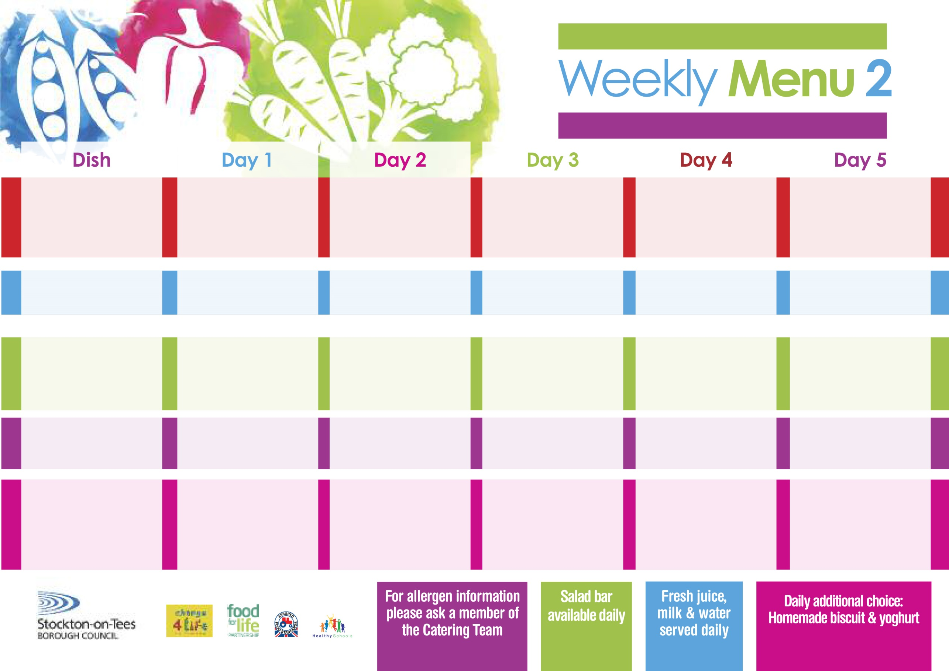

**Breaded Chicken Breast**

**Oven Roasted Potatoes**

**Garden Peas**

**Spaghetti Hoops**

**Macaroni Cheese (V)**

**Homemade Herby Bread**

**Garden Peas**

**Egg Mayonnaise Sandwich (V)**

**Oven Roasted Potatoes**

**Chocolate Crunch**

**with Custard Sauce**

**Cold Bar**

**Fresh Fruit Salad**

**2nd May, 6th June & 4th July, 2022**

**Minced Beef & Yorkshire Puddings**

**Creamed Potatoes**

**Cabbage**

**Mixed Vegetables**

**Quorn Sausages (V)**

**Baked Sausages**

**Oven Roasted Potatoes**

**Spaghetti Hoops**

**Tuna Sandwich**

**Oven Roasted Potatoes**

**Apple Pie**

**with Custard Sauce**

**Cold Bar**

**Fresh Fruit Platter**

**Corned Beef Pie**

**Creamed Potatoes**

**Green Beans**

**Diced Carrots**

**Jacket Potato filled with**

**Tuna, Cheese (V) or**

**Baked Beans (V)**

**Ham Sandwich**

**Baked Potato Wedges**

**Feathered Sponge**

**with Custard Sauce**

**Cold Bar**

**Fresh Fruit Bowl**

**Salmon & Sweet**

**Potato Fishcake**

**Oven Baked Chips**

**Garden Peas**

**Baked Beans**

**Homemade Pizza (V)**

**Oven Baked Chips**

**Garden Peas**

**Baked Beans**

**Egg Mayo Sandwich (V)**

**Oven Baked Chips**

**Rice Pudding**

**with Jam Sauce**

**Cold Bar**

**Melon Boat**

**Sweet & Sour Pork**

**with Rice**

**Broccoli**

**Sweetcorn**

**Sweet & Sour Quorn (V)**

**Fish Fillet Fingers**

**Baked Jacket Potatoes**

**Baked Beans**

**Sweetcorn**

**Cheese Sandwich (V)**

**Baked Jacket Potato**

**Ginger Sponge**

**with Custard Sauce**

**Cold Bar**

**Watermelon Slices**

**Wristband School Menu**

**Red Choice**

**Blue Choice**

**Green Choice**

**Cold Selection**

**Desserts**