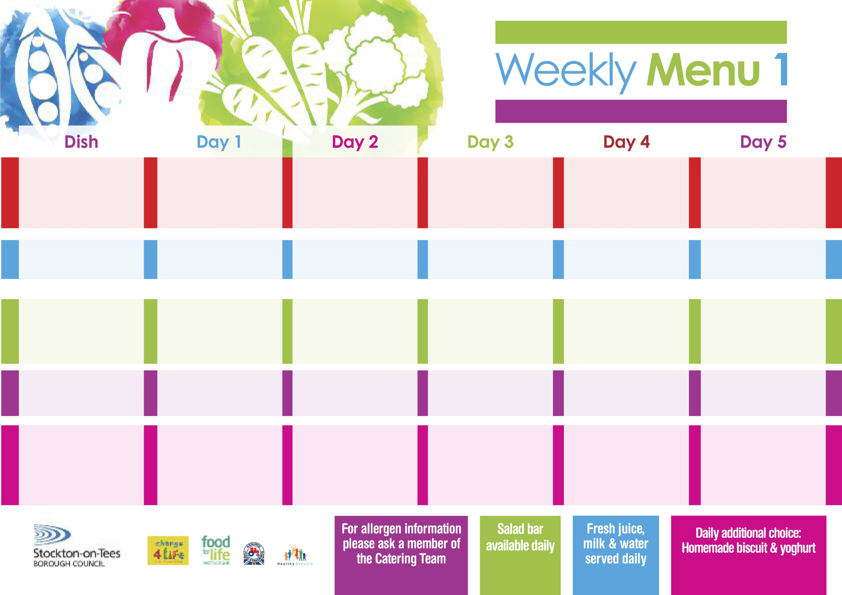

**Chicken Cobbler**

**Baby Boiled Potatoes**

**Cabbage**

**Diced Swede**

**Jacket Potato filled with Tuna, Cheese (V) or Baked Beans (V)**

**Egg Mayonnaise Sandwich (V)**

**Baby Boiled Potatoes**

**Rice Pudding**

**with Jam Sauce**

**Cold Bar**

**Fresh Fruit Salad**

**25th April, 23rd May & 27th June, 2022**

**Minced Beef Pie**

**Creamed Potatoes**

**Diced Carrots**

**Broccoli**

**Cheese Omelette (V)**

**Oven Roasted Potatoes**

**Baked Beans**

**Ham Sandwich**

**Oven Roasted Potatoes**

**Chocolate Sponge**

**with Custard Sauce**

**Cold Bar**

**Melon Boat**

**Spaghetti Bolognaise**

**Homemade Garlic Bread**

**Sweetcorn**

**Baked Cheese &**

**Onion Roll (V)**

**Oven Baked Potato Wedges**

**Spaghetti Hoop**

**Tuna Sandwich**

**Oven Baked Potato Wedges**

**Cornflake Tart**

**with Custard Sauce**

**Cold Bar**

**Watermelon Slices**

**Wristband School Menu**

**+**

**Pork & Carrot Meatballs**

**in Tomato Sauce with**

**Pasta Twirls**

**Garden Peas**

**Quorn Meatballs (V) in Tomato Sauce with**

**Pasta Twirls & Garden Peas**

**Fish Stars**

**Baked Jacket Potatoes**

**Diced Carrots**

**Garden Peas**

**Spaghetti Hoops**

**Cheese Sandwich (V)**

**Baked Jacket Potatoes**

**Apple Crumble**

**with Custard Sauce**

**Cold Bar**

**Fresh Fruit Bowl**

**Fish Goujons**

**Oven Baked Chips**

**Garden Peas**

**Baked Beans**

**Cheese & Tomato Pizza (V)**

**Oven Baked Chips**

**Garden Peas**

**Baked Beans**

**Egg & Cress Sandwich (V)**

**Oven Baked Chips**

**Vanilla Sponge**

**with Custard Sauce**

**Cold Bar**

**Fresh Fruit Bowl**

**Red Choice**

**Blue Choice**

**Green Choice**

**Cold Selection**

**Desserts**