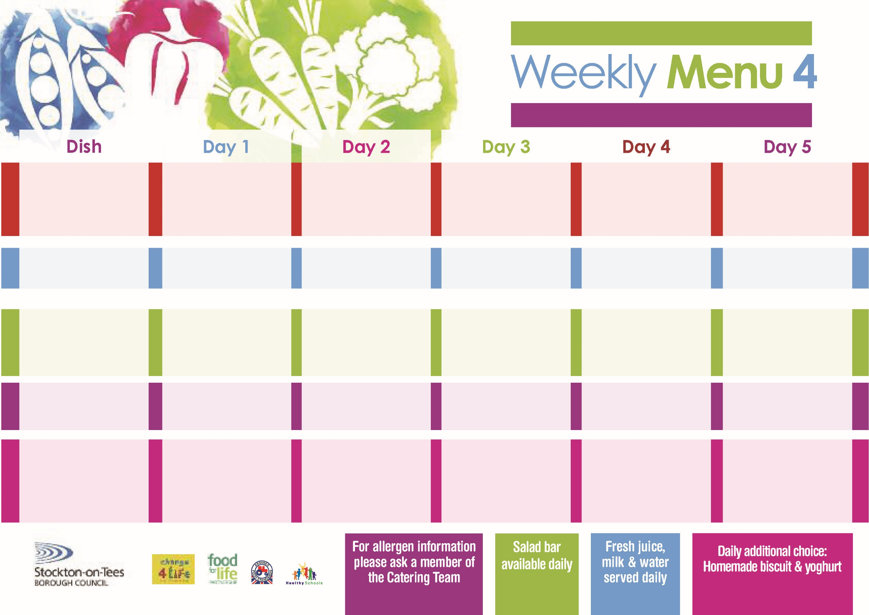

**Fish Goujons**

**Oven Baked Chips**

**Garden Peas**

**Baked Beans**

**Cheese & Tomato Pizza (V)**

**Oven Baked Chips**

**Garden Peas**

**Baked Beans**

**Ham Sandwich**

**Oven Baked Chips**

**Chocolate Lime Sponge**

**with Custard Sauce**

**Cold Bar**

**Fresh Fruit Kebab**

**Beef Burger in a Bun**

**Oven Roasted Potatoes**

**Baked Beans**

**Sweetcorn**

**Quorn Burger in a Bun (V)**

**Fish Fillet Fingers**

**Oven Roasted Potatoes**

**Baked Beans**

**Sweetcorn**

**Tuna Sandwich**

**Oven Roasted Potatoes**

**Creamy Rice Pudding**

**with Jam Sauce**

**Cold Bar**

**Watermelon Slices**

**Pork & Carrot Meatballs**

**In Rich Onion Gravy**

**Creamed Potatoes**

**Broccoli**

**Diced Carrots**

**Jacket Potato filled with**

**Tuna, Cheese (V) or**

**Baked Beans (V)**

**Egg Mayonnaise Sandwich (V)**

**Baked Jacket Potatoes**

**Jam Sponge**

**with Custard Sauce**

**Cold Bar**

**Fresh Fruit Bowl**

**24th January, 28th February & 28th March, 2022**

**Chicken Cobbler**

**Baby Boiled Potatoes**

**Cauliflower**

**Diced Swede**

**Baked Quorn Sausages (V)**

**Baked Sausages**

**Baby Boiled Potatoes**

**Spaghetti Hoops**

**Cheese Wrap (V)**

**Baby Boiled Potatoes**

**Eve’s Pudding**

**with Custard Sauce**

**Cold Bar**

**Fresh Fruit Salad**

**Minced Beef Pie**

**Creamed Potatoes**

**Garden Peas**

**Diced Carrots**

**Cheese Omelette (V)**

**Oven Baked Jacket Potato**

**Garden Peas**

**Baked Beans**

**Tuna Sandwich**

**Oven Baked Jacket Potato**

**Bakewell Tart**

**with Custard Sauce**

**Cold Bar**

**Melon Boat**

**Red Choice**

**Blue Choice**

**Green Choice**

**Cold Selection**

**Desserts**

**Wristband School Menu**