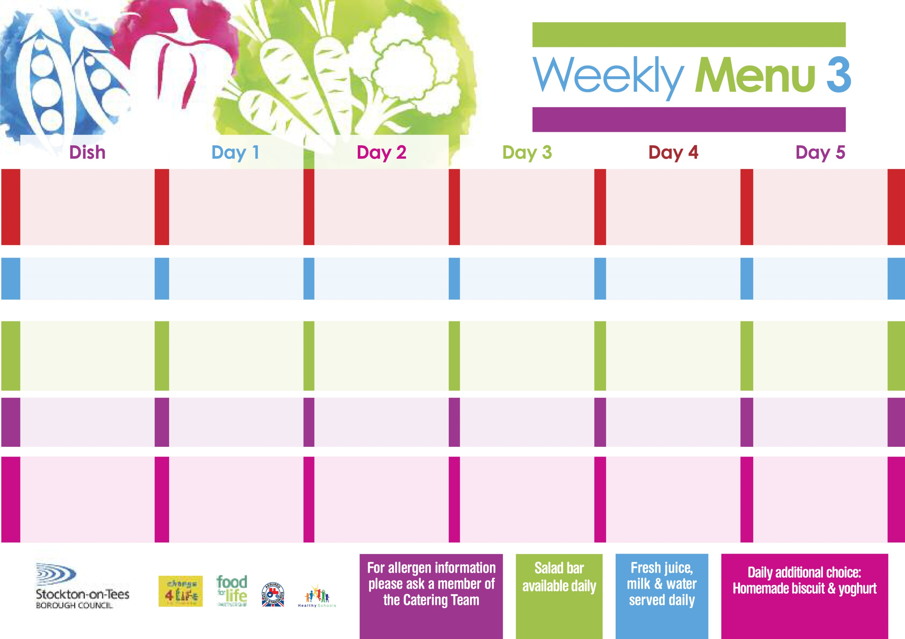

**17th January, 14th February & 21st March, 2022**

**Tempura Battered Fish Fillet**

**Oven Baked Chips**

**Garden Peas**

**Baked Beans**

**Jacket Potato filled with**

**Tuna, Cheese (V) or**

**Baked Beans (V)**

**Egg Mayonnaise Sandwich (V)**

**Oven Baked Chips**

**Ginger Sponge**

**with Custard Sauce**

**Cold Bar**

**Fresh Fruit Platter**

**Sweet & Sour Pork**

**Rice**

**Mixed Vegetables**

**Pizza (V)**

**Oven Baked Potato Wedges**

**Baked Beans**

**Ham Sandwich**

**Oven Baked Potato Wedges**

**Apple & Rhubarb Pie**

**with Custard Sauce**

**Cold Bar**

**Fresh Fruit Bowl**

**Chicken & Vegetables with a Puff Pastry Lid**

**Oven Roasted Potatoes**

**Cauliflower**

**Cabbage**

**Diced Quorn & Vegetables with a Puff Pastry Lid (V)**

**Fish Cake**

**Oven Roasted Potatoes**

**Spaghetti Hoops**

**Cheese Wrap (V)**

**Oven Roasted Potatoes**

**Creamy Rice Pudding**

**with Peaches**

**Cold Bar**

**Melon Boats**

**Roast Beef &**

**Yorkshire Pudding**

**Oven Roasted Potatoes**

**Broccoli**

**Cabbage**

**Cheese Pasty**

**Oven Roasted Potatoes**

**Spaghetti Hoops**

**Cheese Sandwich (V)**

**Oven Roasted Potatoes**

**Festival Shortcake**

**with Custard Sauce**

**Cold Bar**

**Fresh Fruit Salad**

**Spaghetti Bolognaise**

**Homemade Garlic Bread**

**Sweetcorn**

**Garden Peas**

**Quorn Bolognaise (V)**

**Sausage Roll**

**Oven Roasted Potatoes**

**Garden Peas**

**Sweetcorn**

**Tuna Sandwich**

**Oven Roasted Potatoes**

**Pineapple Upside Down Cake**

**with Custard Sauce**

**Cold Bar**

**Fresh Fruit Kebab**

**Red Choice**

**Blue Choice**

**Green Choice**

**Cold Selection**

**Desserts**

**Wristband School Menu**