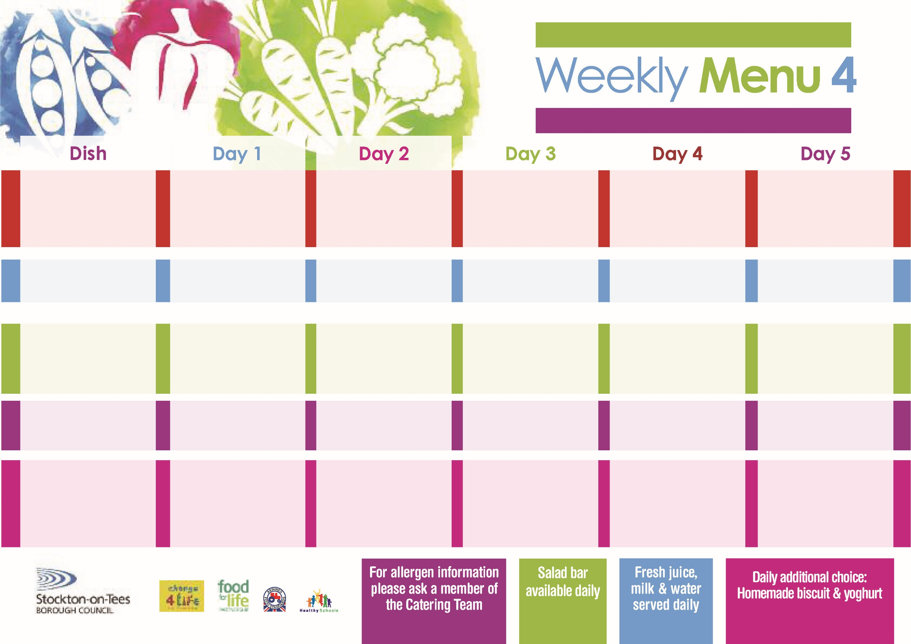

**Fish Goujons**

**Oven Baked Chips**

**Garden Peas**

**Baked Beans**

**Corned Beef Pie**

**Oven Baked Chips**

**Garden Peas**

**Baked Beans**

**Egg Wrap (V)**

**Oven Baked Chips**

**Feathered Sponge**

**with Custard Sauce**

**Cold Bar**

**Fresh Fruit Kebab**

**Toad in the Hole**

**Baby Boiled Potatoes**

**Broccoli**

**Diced Swede**

**Quorn Sausages with Yorkshire Pudding (V)**

**Jacket Potato filled with**

**Tuna, Cheese (V) or**

**Baked Beans (V)**

**Tuna Sandwich**

**Oven Baked Jacket Potato**

**Bakewell Tart**

**with Custard Sauce**

**Cold Bar**

**Watermelon Slices**

**Beef Burger in a Bun**

**Oven Roasted Potatoes**

**Baked Beans**

**Garden Peas**

**Quorn Burger in a Bun (V)**

**Fish Cake in a**

**Natural Crumb**

**Oven Roasted Potatoes**

**Garden Peas**

**Baked Beans**

**Cheese Sandwich (V)**

**Oven Roasted Potatoes**

**Jam Sponge**

**with Custard Sauce**

**Cold Bar**

**Fresh Fruit Bowl**

**20th September, 18th October & 22nd November, 2021**

**Ham & Mushroom**

**Pasta Bake**

**Homemade Cheese Bread**

**Cauliflower**

**Sweetcorn**

**Homemade Pizza (V)**

**Oven Baked Potato Wedges**

**Spaghetti Hoops**

**Tuna Wrap**

**Oven Baked Jacket Potatoes**

**Oaty Apple & Pear Crumble**

**with Custard Sauce**

**Cold Bar**

**Fresh Fruit Salad**

**Mediterranean Bolognaise**

**with Pasta Twirls**

**Homemade Garlic Bread**

**Diced Carrots**

**Mixed Vegetables**

**Mediterranean Quorn Bolognaise with Pasta Twirls (V)**

**Baked Cheese Rolls (V)**

**Oven Baked Jacket Potato**

**Diced Carrots**

**Mixed Vegetables**

**Egg Sandwich (V)**

**Oven Baked Jacket Potato**

**Syrup Sponge**

**with Custard Sauce**

**Cold Bar**

**Melon Boat**

**Red Choice**

**Blue Choice**

**Green Choice**

**Cold Selection**

**Desserts**

**Wristband School Menu**