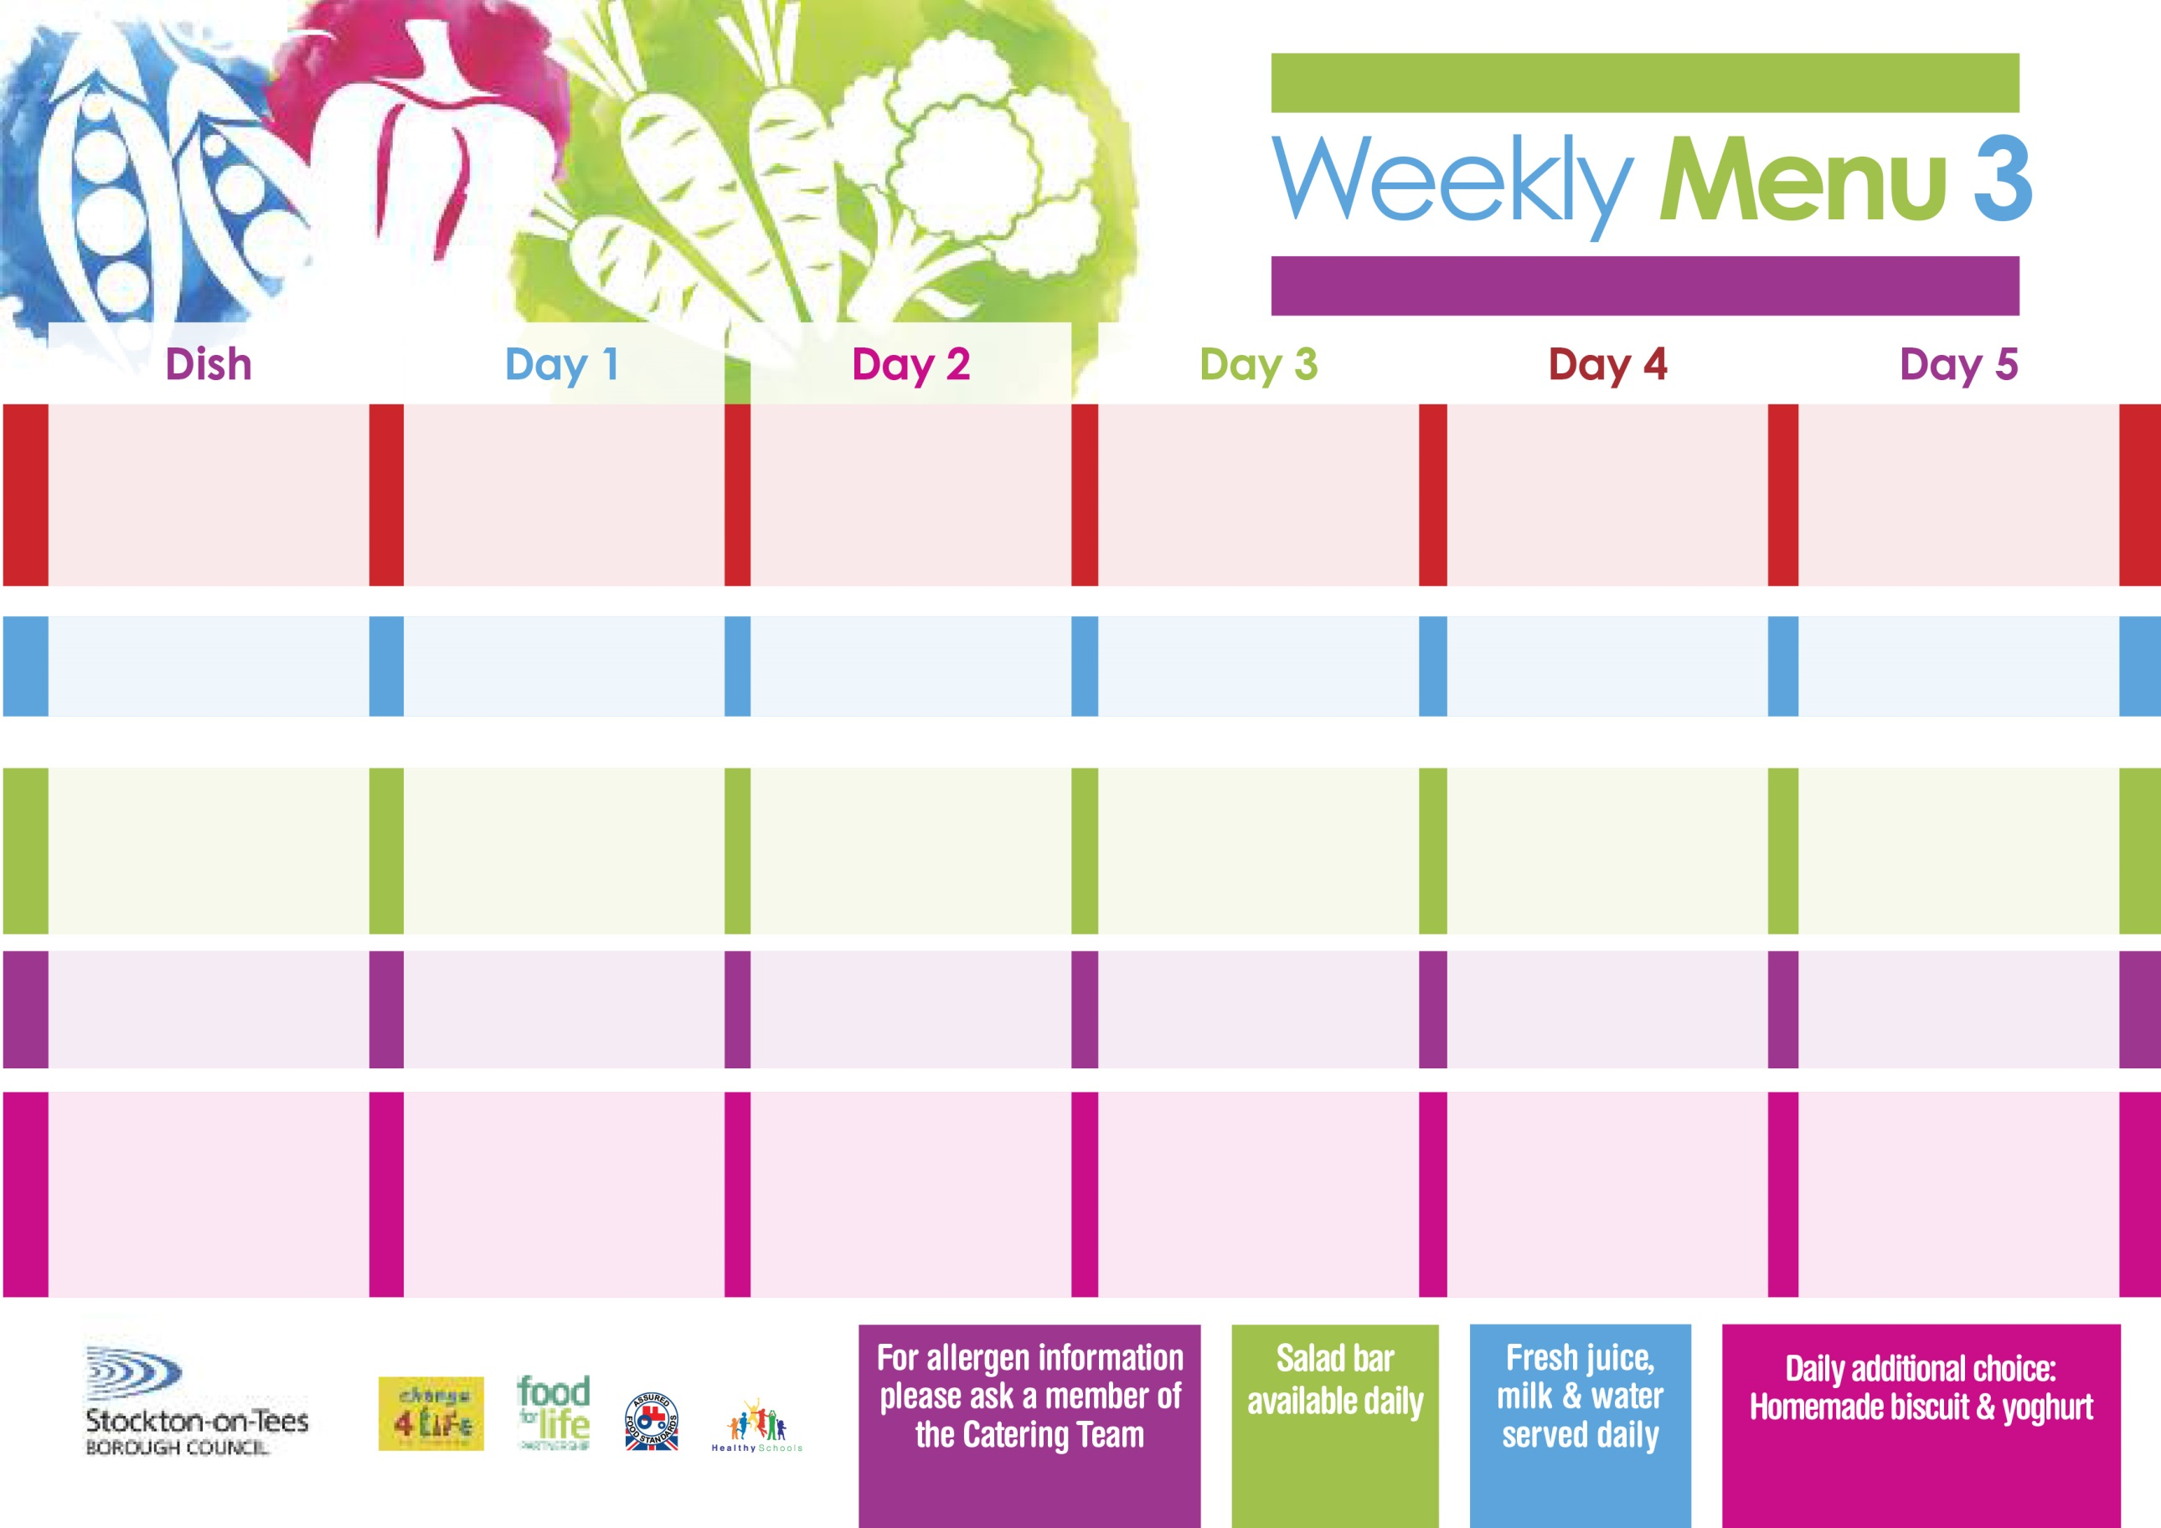

**13th September, 11th October & 15th November & 13th December, 2021**

**Salmon & Sweet Potato Fishcake**

**Oven Baked Chips**

**Garden Peas**

**Baked Beans**

**Cheese & Tomato**

**Pizza Whirls (V)**

**Oven Baked Chips**

**Garden Peas**

**Baked Beans**

**Egg Mayonnaise Sandwich (V)**

**Oven Baked Chips**

**Mandarin Orange Sponge**

**with Custard Sauce**

**Cold Bar**

**Fresh Fruit Platter**

**Chicken Casserole with Herby Dumplings**

**Oven Roasted Potatoes**

**Diced Carrots**

**Cauliflower**

**Baked Quorn Sausages (V)**

**Baked Sausages**

**Oven Roasted Potatoes**

**Baked Beans**

**Cheese Sandwich (V)**

**Oven Roasted Potatoes**

**Festival Shortcake**

**with Custard Sauce**

**Cold Bar**

**Fresh Fruit Bowl**

**Lasagne**

**Homemade Garlic Bread**

**Mixed Vegetables**

**Green Beans**

**Quorn Lasagne (V)**

**Fish Fillet Fingers**

**Baked Jacket Potatoes**

**Spaghetti Hoops**

**Egg Mayonnaise Wrap (V)**

**Baked Jacket Potato**

**Chocolate Sponge**

**with Custard Sauce**

**Cold Bar**

**Melon Boats**

**Roast Beef &**

**Yorkshire Pudding**

**Creamed Potatoes**

**Broccoli**

**Cabbage**

**Jacket Potato filled with**

**Tuna, Cheese (V) or**

**Baked Beans (V)**

**Tuna Sandwich**

**Baked Jacket Potatoes**

**Rice Pudding & Fruit**

**Cold Bar**

**Fresh Fruit Salad**

**Chicken Curry**

**Hot Rice**

**Sweetcorn**

**Garden Peas**

**Quorn Curry (V)**

**Sausage Roll**

**Oven Roasted Potatoes**

**Garden Peas**

**Baked Beans**

**Tuna Sandwich**

**Oven Roasted Potatoes**

**Lemon Sponge**

**with Custard Sauce**

**Cold Bar**

**Fresh Fruit Kebab**

**Red Choice**

**Blue Choice**

**Green Choice**

**Cold Selection**

**Desserts**

**Wristband School Menu**