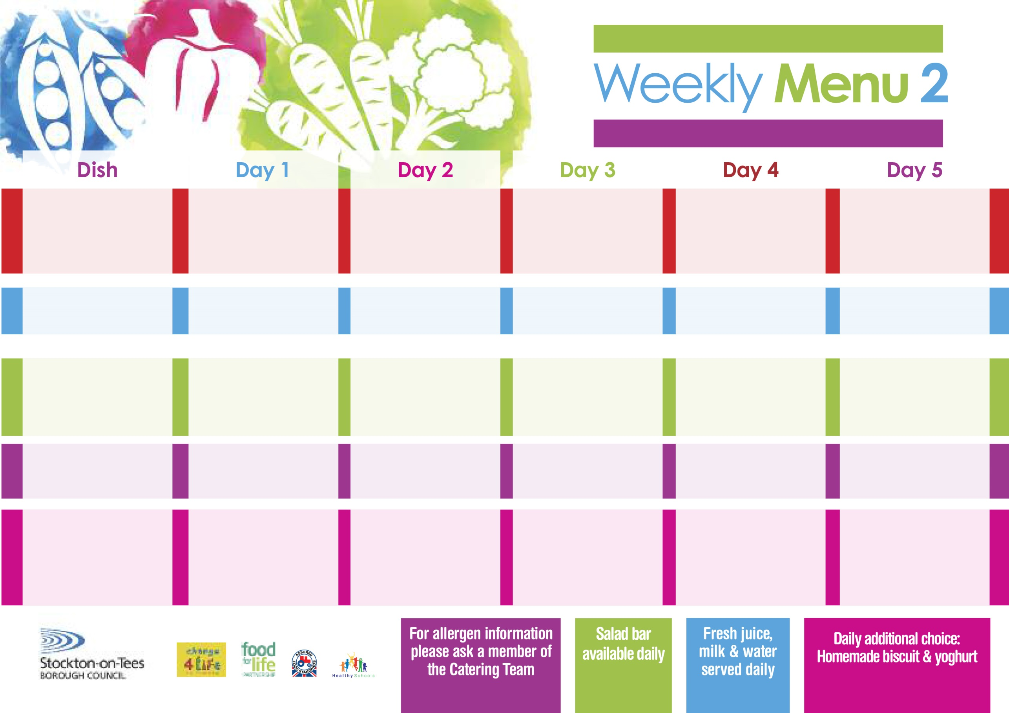

**6th September, 4th October, 8th November & 6th December, 2021**

**Roast Gammon served with Pineapple**

**Oven Roasted Potatoes**

**Broccoli**

**Cauliflower**

**Pizza (V)**

**Oven Roasted Potatoes**

**Spaghetti Hoops**

**Cheese Wrap (V)**

**Oven Roasted Potatoes**

**Vanilla Sponge**

**with Custard Sauce**

**Cold Bar**

**Fresh Fruit Platter**

**Minced Beef & Dumplings**

**Creamed Potatoes**

**Mixed Vegetables**

**Sweetcorn**

**Quorn Mince & Dumplings (V)**

**Fish Stars**

**Oven Baked Jacket Potato**

**Sweetcorn**

**Spaghetti Hoops**

**Tuna Sandwich**

**Oven Baked Jacket Potato**

**Chocolate Chip Sponge**

**with Custard Sauce**

**Cold Bar**

**Fresh Fruit Salad**

**Buttermilk Chicken**

**Baked Potato Wedges**

**Garden Peas**

**Baked Beans**

**Macaroni Cheese (V)**

**Homemade Herby Bread**

**Garden Peas**

**Ham Sandwich**

**Baked Potato Wedges**

**Cornflake Tart**

**with Custard Sauce**

**Cold Bar**

**Fresh Fruit Bowl**

**Harry Ramsden**

**Fish Fillet**

**Oven Baked Chips**

**Garden Peas**

**Baked Beans**

**Cheese Pasty (V)**

**Oven Baked Chips**

**Garden Peas**

**Baked Beans**

**Tuna Sandwich**

**Oven Baked Chips**

**Creamy Rice Pudding**

**& Jam Sauce**

**Cold Bar**

**Melon Boat**

**Pork & Carrot Meatballs In Tomato Sauce with Pasta**

**Homemade Garlic Bread**

**Diced Carrots**

**Green Beans**

**Jacket Potato filled with**

**Tuna, Cheese (V) or**

**Baked Beans (V)**

**Egg Mayonnaise Wrap (V)**

**Oven Baked Jacket Potato**

**Pineapple Upside Down**

**with Custard Sauce**

**Cold Bar**

**Watermelon Slices**

**Wristband School Menu**

**Red Choice**

**Blue Choice**

**Green Choice**

**Cold Selection**

**Desserts**