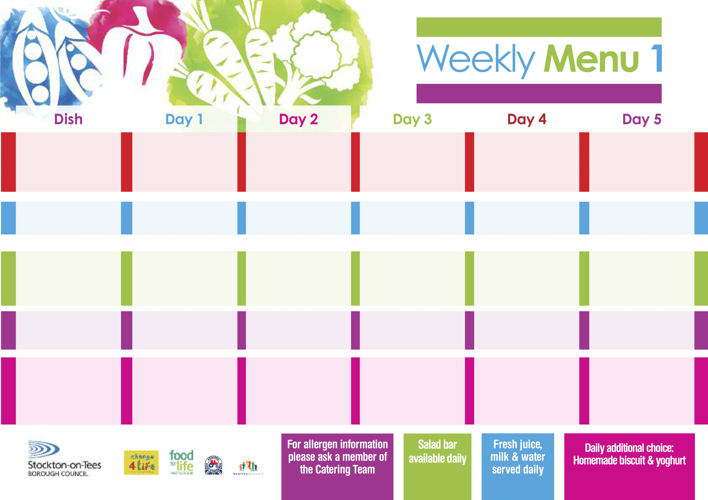

**30thAugust, 27th September, 1st November & 29th November, 2021**

**Pork & Vegetable Pie**

**Creamed Potatoes**

**Diced Carrots**

**Garden Peas**

**Quorn Casserole & Dumplings**

**(V)**

**Fish Fillet Fingers**

**Oven Baked Jacket Potato**

**Diced Carrots**

**Garden Peas**

**Tuna Sandwich**

**Baked Jacket Potatoes**

**Chocolate Crunch**

**with Custard Sauce**

**Cold Bar**

**Fresh Fruit Salad**

**Breaded Chicken Breast**

**Oven Roasted Potatoes**

**Sweetcorn**

**Broccoli**

**Penne Pasta in**

**Tomato Sauce (V)**

**Homemade Cheese Bread**

**Sweetcorn**

**Broccoli**

**Egg Mayonnaise Wrap** **(V)**

**Oven Roasted Potatoes**

**Jam Roly Poly**

**with Custard Sauce**

**Cold Bar**

**Melon Boat**

**Roast Turkey served with Sage & Onion Stuffing**

**Oven Roasted Potatoes**

**Cauliflower**

**Diced Swede**

**Pizza (V)**

**Oven Roasted Potatoes**

**Spaghetti Hoops**

**Egg Mayonnaise Wrap (V)**

**Oven Roasted Potatoes**

**Apple Crumble**

**with Custard Sauce**

**Cold Bar**

**Watermelon Slices**

**Wristband School Menu**

**+**

**Spaghetti Bolognaise**

**Homemade Garlic Bread**

**Diced Carrots**

**Green Beans**

**Quorn Bolognaise (V)**

**Jacket Potato filled with**

**Tuna, Cheese (V) or**

**Baked Beans (V)**

**Cheese Sandwich (V)**

**Baked Jacket Potatoes**

**Marble Sponge**

**with Custard Sauce**

**Cold Bar**

**Fresh Fruit Bowl**

**Fish Goujons**

**Oven Baked Chips**

**Garden Peas**

**Baked Beans**

**Cheese Omelette (V)**

**Oven Baked Chips**

**Garden Peas**

**Baked Beans**

**Cheese Sandwich (V)**

**Oven Baked Chips**

**Rice Pudding**

**with Jam Sauce**

**Cold Bar**

**Fresh Fruit Bowl**

**Red Choice**

**Blue Choice**

**Green Choice**

**Cold Selection**

**Desserts**