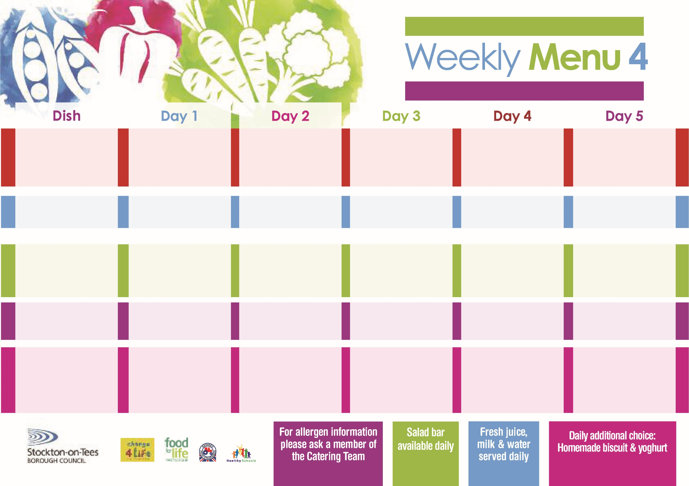

**Tempura Battered**

**Fish Fillet**

**Oven Baked Chips**

**Garden Peas**

**Baked Beans**

**Jacket Potato filled with**

**Tuna, Cheese (V) or**

**Baked Beans (V)**

**Egg Wrap (V)**

**Oven Baked Chips**

**Apple Crumble**

**with Custard Sauce**

**Cold Bar**

**Fresh Fruit Kebab**

**Toad in the Hole**

**Baby Boiled Potatoes**

**Broccoli**

**Diced Swede**

**Quorn Sausages with Yorkshire Pudding (V)**

**Cheese Pasty (V)**

**Oven Baked Jacket Potato**

**Broccoli**

**Spaghetti Hoops**

**Tuna Sandwich**

**Oven Baked Jacket Potato**

**Creamy Rice Pudding**

**& Jam Sauce**

**Cold Bar**

**Watermelon Slices**

**Sweet & Sour Chicken**

**Hot Rice**

**Garden Peas**

**Mixed Vegetables**

**Quorn Burger in a Bun (V)**

**Beef Burger in a Bun**

**Oven Roasted Potatoes**

**Garden Peas**

**Baked Beans**

**Cheese Sandwich (V)**

**Oven Roasted Potatoes**

**Apple Crumble**

**with Custard Sauce**

**Cold Bar**

**Fresh Fruit Bowl**

**3rd May, 7th June & 5th July, 2021**

**Mince & Dumplings**

**Creamed Potatoes**

**Cauliflower**

**Diced Carrots**

**Homemade Pizza (V)**

**Oven Baked Jacket Potatoes**

**Spaghetti Hoops**

**Tuna Wrap**

**Oven Baked Jacket Potatoes**

**Mandarin Orange Sponge**

**with Custard Sauce**

**Cold Bar**

**Fresh Fruit Salad**

**Mediterranean Bolognaise**

**with Pasta Twirls**

**Homemade Garlic Bread**

**Garden Peas**

**Sweetcorn**

**Mediterranean Quorn Bolognaise with Pasta Twirls (V)**

**Fish Cake in Natural Crumb**

**Oven Baked Potato Wedges**

**Garden Peas**

**Sweetcorn**

**Egg Sandwich (V)**

**Oven Baked Potato Wedges**

**Syrup Roly Poly**

**with Custard Sauce**

**Cold Bar**

**Melon Boat**

**Red Choice**

**Blue Choice**

**Green Choice**

**Cold Selection**

**Desserts**

**Wristband School Menu**