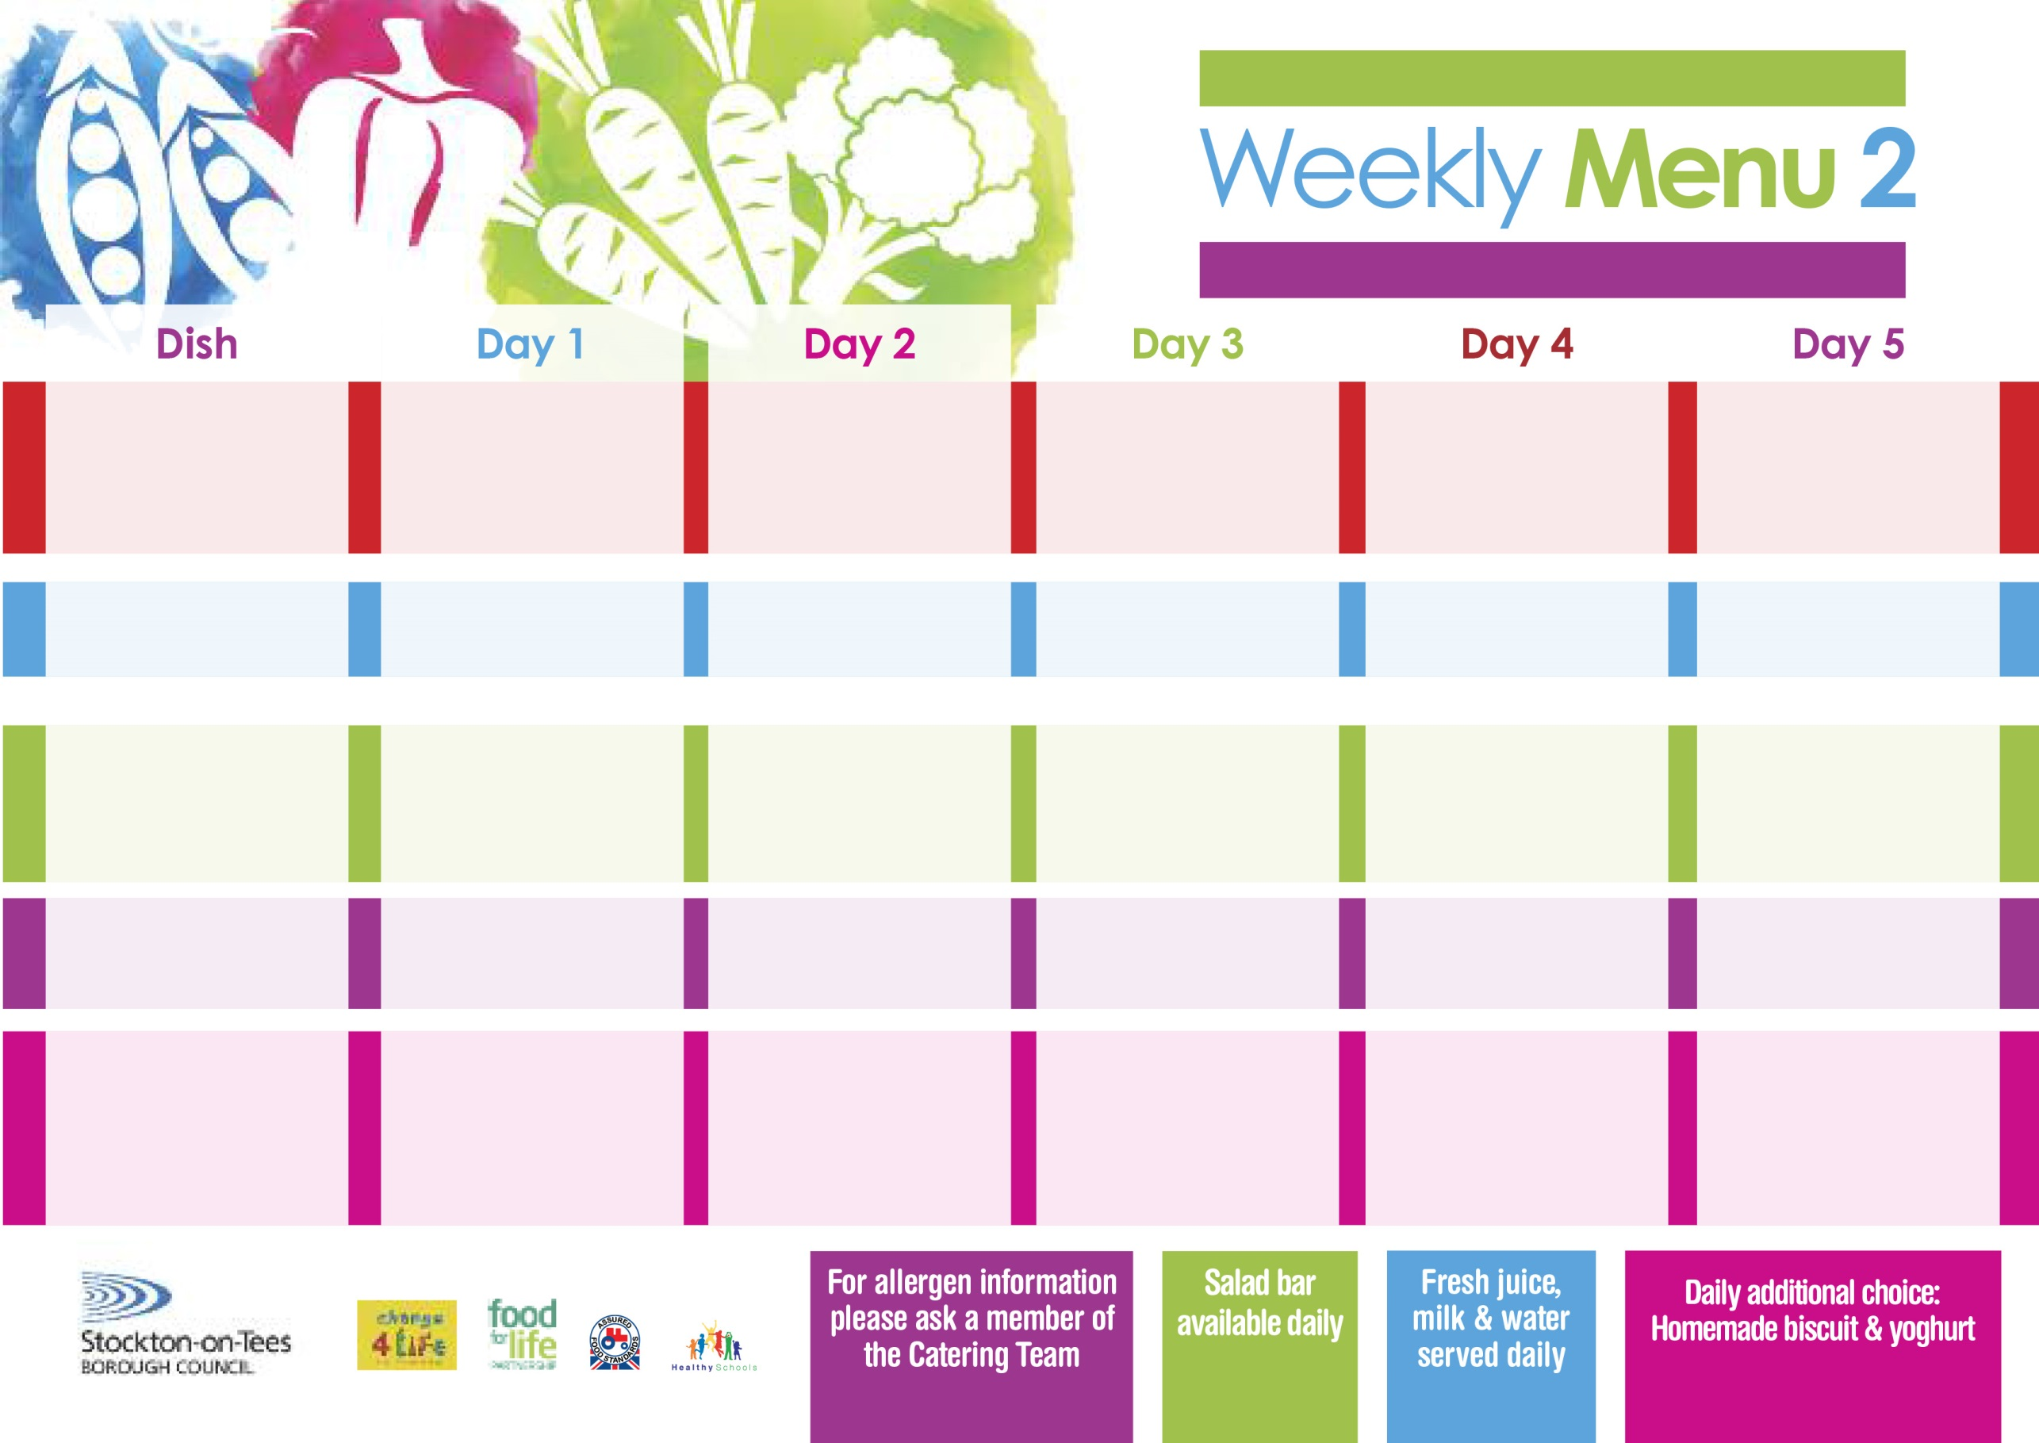

**19th April, 17th May, 21st June & 19th July, 2021**

**Roast Turkey served with Sage & Onion Stuffing**

**Creamed Potatoes**

**Baton Carrots**

**Cauliflower**

**Jacket Potato filled with**

**Tuna, Cheese (V) or**

**Baked Beans (V)**

**Cheese Wrap (V)**

**Oven Baked Jacket Potatoes**

**Festival Shortcake**

**with Custard Sauce**

**Cold Bar**

**Fresh Fruit Platter**

**Pork & Carrot Meatballs In Tomato Sauce with Pasta**

**Homemade Garlic Bread**

**Sweetcorn**

**Mixed Vegetables**

**Quorn Bolognaise (V)**

**Sausage Roll**

**Oven Baked Potato Wedges**

**Sweetcorn**

**Spaghetti Hoops**

**Tuna Sandwich**

**Oven Baked Potato Wedges**

**Marble Sponge**

**with Custard Sauce**

**Cold Bar**

**Fresh Fruit Salad**

**Minced Beef Pie**

**Baby Boiled Potatoes**

**Broccoli**

**Mixed Vegetables**

**Minced Quorn Pie (V)**

**Fish Stars**

**Baby Boiled Potatoes**

**Baked Beans**

**Ham Sandwich**

**Baby Boiled Potatoes**

**Jam Sponge**

**with Custard Sauce**

**Cold Bar**

**Fresh Fruit Bowl**

**Harry Ramsden**

**Fish Fillet**

**Oven Baked Chips**

**Garden Peas**

**Baked Beans**

**Pizza Whirl (V)**

**Oven Baked Chips**

**Garden Peas**

**Baked Beans**

**Tuna Sandwich**

**Oven Baked Chips**

**Creamy Rice Pudding**

**& Jam Sauce**

**Cold Bar**

**Melon Boat**

**Breaded Chicken Breast**

**Oven Roasted Potatoes**

**Garden Peas**

**Diced Carrots**

**Macaroni Cheese (V)**

**Oven Roasted Potatoes**

**Garden Peas**

**Diced Carrots**

**Egg Mayonnaise Wrap (V)**

**Oven Roasted Potatoes**

**Lemon Roly Poly**

**with Custard Sauce**

**Cold Bar**

**Watermelon Slices**

**Wristband School Menu**

**Red Choice**

**Blue Choice**

**Green Choice**

**Cold Selection**

**Desserts**