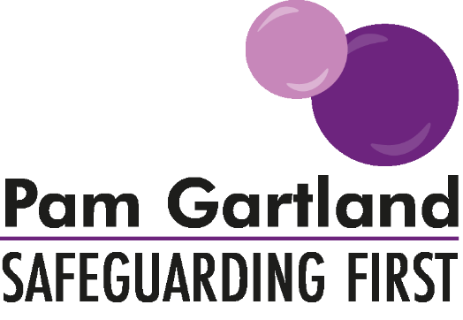

Addendum to Child Protection Policy due to the circumstances of COVID-19

Due to the current unprecedented circumstances of the COVID-19 virus it is necessary that all schools are prepared and have appropriate arrangements in place in relation to the management of any safeguarding or child protection concerns both on and off site during this time. Therefore, we have produced this cover note/addendum to our existing school’s Child Protection Policy Template to ensure all staff, Governors and Parents understand our protocols for managing child protection concerns during this time.
Designated Safeguarding Leads and Deputies
On Site: While our school site remains open for vulnerable children and children of key workers, the Designated Safeguarding Leads/Deputies are (_S.Hawes/J.Whitehill_______) and continue to be our Designated Safeguarding Leads/Deputies due to their level of training and skill. However due to these unprecedented circumstances they may not physically be on our school site every day. In this case the following named individuals will be physically on site each day and will liaise directly with the Designated Safeguarding Leads/Deputies if any incidents of a child protection nature occur.
- Monday J.Whitehill
- Tuesday J.Whitehill
- Wednesday J.Whitehill
- Thursday J.Whitehill
- Friday J.Whitehill

During Mrs Hawes absence Mrs J Armstrong is also available every day as a DSL at Wolviston Primary

Should our school site be entirely closed then we will update our website and Child Protection Policy with our arrangements.
Off Site: While our school site is closed during these unprecedented circumstances, the Designated Safeguarding Leads/Deputies are (S.Hawes/J.Whitehill) and continue to be our Designated Safeguarding Leads/Deputies due to their level of training and skill. While we are closed our Designated Safeguarding Leads/Deputies will continue to remain in contact with those children who we deem are vulnerable or have a multi-agency statutory plan in place to safeguard them.

Children moving across provisions due to school closures
Due to these unprecedented circumstances if our school has chosen to close we can send our vulnerable children to the nearest Primary school or a Primary within our Trust. Information regarding these children has been shared between our school and theirs in the interests of safeguarding and protecting our children. This information has followed appropriate confidentiality protocols and is in line with the GDPR and Data Protection Act.

Arrangements for Contact with Vulnerable Children
Where our school remains open, the Designated Safeguarding Leads and Deputies are fully aware of their vulnerable children and those they are expecting into school each day, should that child not arrive then the Designated Safeguarding Lead or Deputy will make contact with the parent or carer immediately and if no response contact front door services immediately.

Designated Safeguarding Leads/Deputies will continue to contact vulnerable children and their families in the following timescales if the school is closed or these children are not on site: children the subject of a Child Protection Plan (daily), children who have a Child in Need Plan (twice weekly), Looked After Children (twice weekly dependent on the child’s individual placement needs) or children with an Early Help Plan (weekly). If there are any issues raised during this time regarding their care, safety or ability to be contacted then the Designated Safeguarding Lead/Deputy will follow their local safeguarding procedures and contact their local front door services immediately (as per our Child Protection Policy).

Availability and contact arrangements for families and professionals who wish to make contact with the Designated Safeguarding Leads/Deputies
During these unprecedented circumstances the Designated Safeguarding Leads/Deputies will be available to be contacted by children, families and other services and agencies to ensure the safety and well-being of all our vulnerable children. They can be contacted via the school telephone number in the first instance and whether they are on or off site they will gain contact with any family or professional as soon as possible.

Contact with the Designated Safeguarding Leads/Deputies should be within the hours of the school day 9am-3.30pm ONLY. Designated Safeguarding Leads/Deputies cannot be responsible for not receiving calls and messages outside of these times. In the event that children or families need support immediately please contact our front door services immediately (as per the information within the Child Protection Policy) or contact the Police.
Response to safeguarding or child protection concerns
As always our school’s duty of care is to keep children safe and while the arrangements of the physical care of children and physical presence of our Designated Safeguarding Leads/Deputies may be different during this time the school’s response remains the same and follows the guidelines as set out in our school’s Child Protection Policy.

Re-issued January 2021

