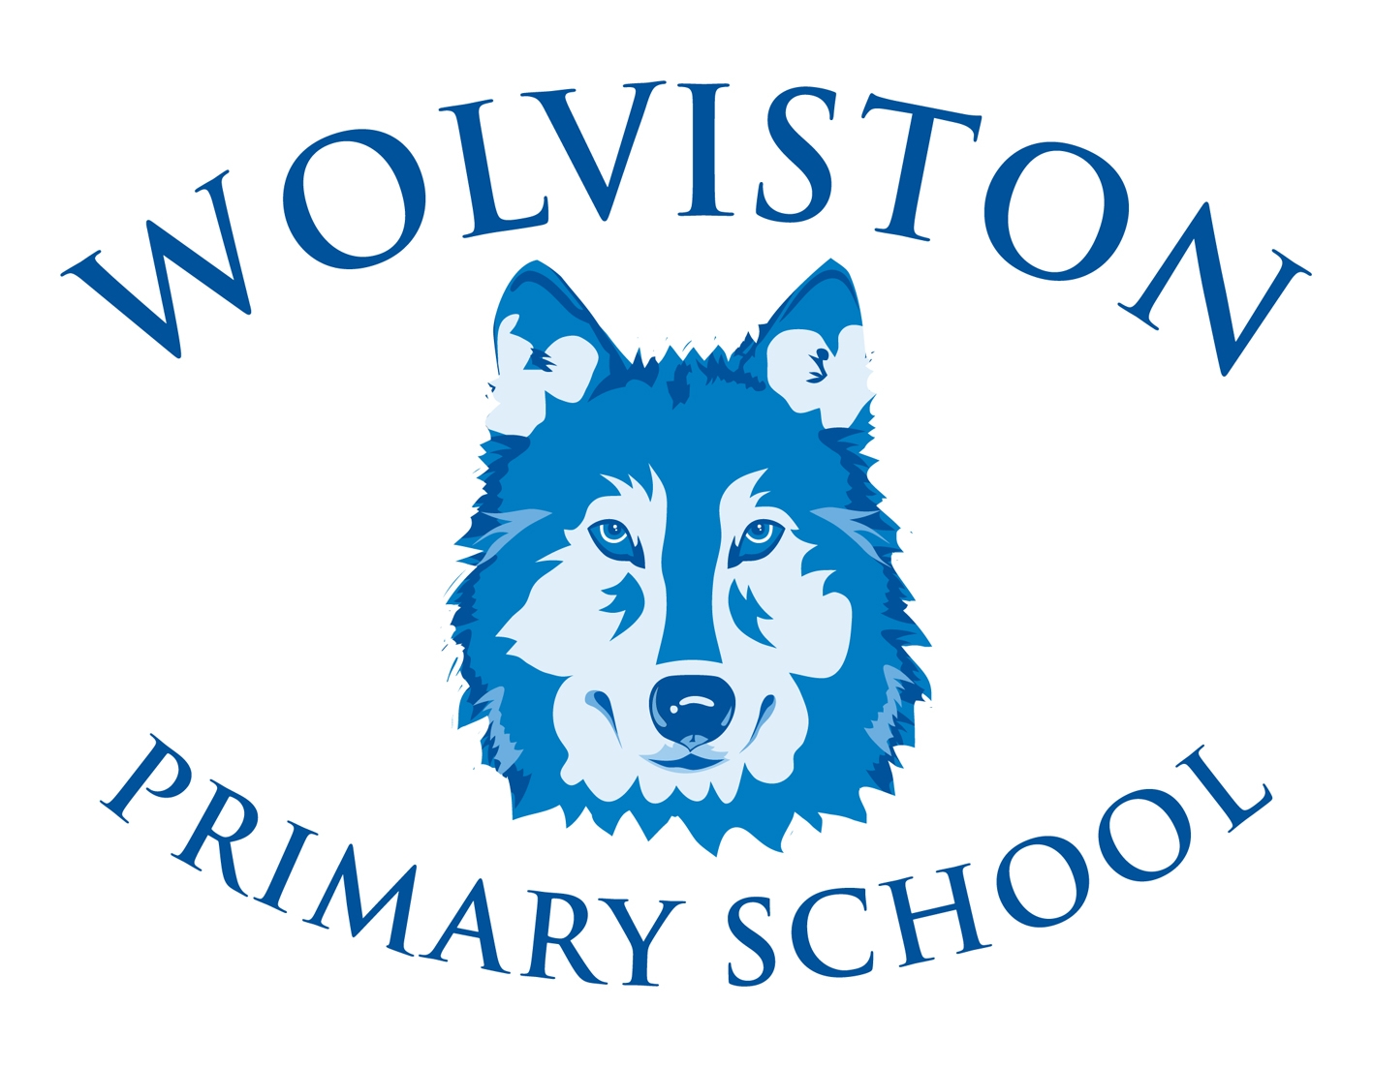

Wolviston Primary School
Head Teacher - Mrs C Haycock B.A. (Hons)
The Green, Wolviston, Billingham, Stockton TS22 5LN
E-Mail enquiries@wolviston.org.uk
Tel: 01740 644374

24th November 2020

Dear Pupils, Parents and Carers,

It is with great pleasure that I write this letter to you. I feel incredibly privileged to have been chosen to lead Wolviston Primary School in the role of Head Teacher. I wanted to take this opportunity to briefly introduce myself and to express my passion for teaching and learning and my enthusiasm for the exciting times ahead.

My name is Susan Hawes and I am currently the Deputy Head Teacher at Hartburn Primary School. I have had five happy and successful years in this role, and although I will be sad to leave, I am ready and excited for the challenge ahead. Prior to working at Hartburn, I worked in schools in North Yorkshire and Middlesbrough. I have been a teacher for over twenty-five years, teaching across the primary age range in a range of schools, including those of different sizes and contexts. I have lived in the area since childhood and thoroughly enjoy all that the Tees Valley has to offer. My husband and I have four children. Two are currently studying at university and our younger two attend our local secondary school. My family and I enjoy a range of activities together, especially those outdoors that can include our golden retriever, Maple.

I strongly believe in a child-centred approach, where consistency, praise, encouragement yet challenge are key. All children are unique and it is an absolute privilege, as a teacher and as a leader, to be able to inspire, enthuse, motivate and nurture them to fully achieve their maximum potential in all areas of their growth and development. I am passionate, dedicated and driven by my core values that include honesty, respect and integrity. As a school and community, I believe we should aspire for excellence and I am committed to ensuring that your child has the highest standard of education. I am a firm believer in providing an ambitious, broad curriculum where talents can develop and shine in a nurturing, happy and safe environment. My ambition is for all our children to become inquisitive, global citizens who are well prepared for their journey into our ever-changing world.

I intend to build on the outstanding work currently being carried out in school, which has been led so well by Mrs Haycock. The energy and enthusiasm that she and her team demonstrate is something I have already noticed and I am excited to maintain.

I would like to take this opportunity to thank the pupils, staff and governors who have made me feel incredibly welcome during my recent visits. Seeing their enthusiasm and love for the school has made it an easy decision for me to want to be your new Head Teacher. Over the last few weeks, I have been working closely with Mrs Haycock (albeit it virtually!) in order for me to successfully lead the school forward from January 2021.

As your new Head Teacher, I am very much looking forward to serving the Wolviston community and working hard to ensure the very best for our children.
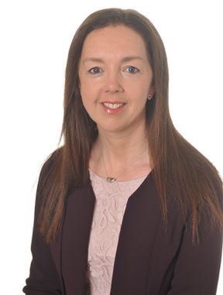
Yours faithfully,

Mrs. S. Hawes

