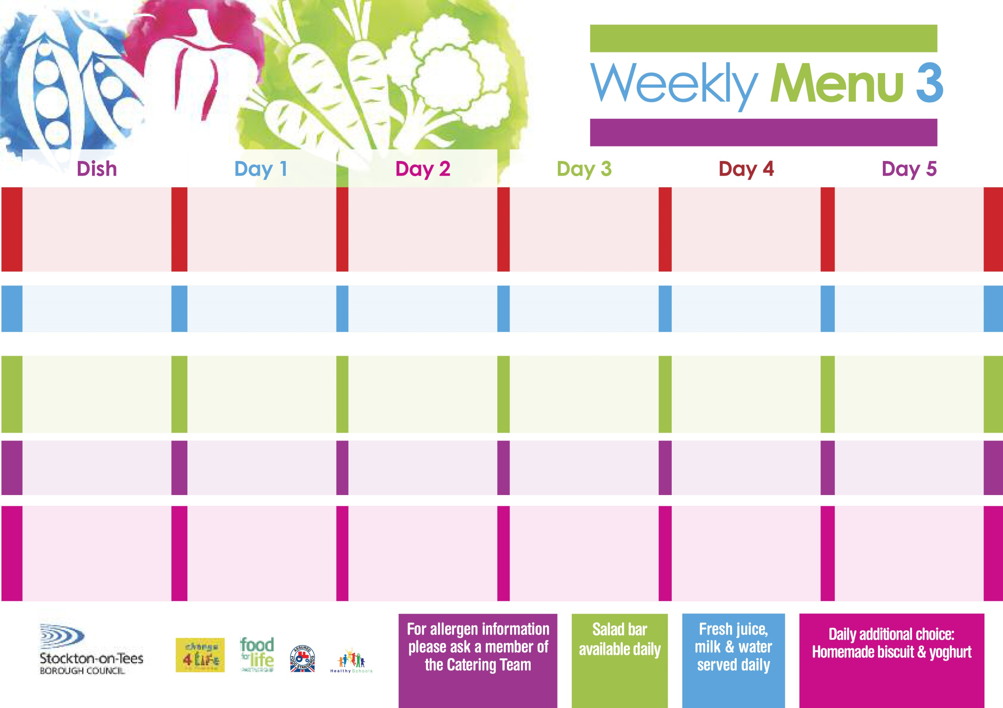

**14th September, 12th October, 16th November & 14th December, 2020**

**Fish Goujons**

**Oven Baked Chips**

**Garden Peas**

**Baked Beans**

**Baked Cheese & Onion Rolls (V)**

**Oven Baked Chips**

**Garden Peas**

**Baked Beans**

**Egg Mayonnaise Sandwich (V)**

**Oven Baked Chips**

**Cornflake Tart**

**with Custard Sauce**

**Cold Bar**

**Fresh Fruit Platter**

**Pork Goulash**

**Hot Rice**

**Mixed Vegetables**

**Quorn Goulash (V)**

**Homemade Margarita Pizza (V)**

**Oven Roasted Potatoes**

**Baked Beans**

**Cheese Sandwich (V)**

**Oven Roasted Potatoes**

**Mixed Fruit Pie**

**with Custard Sauce**

**Cold Bar**

**Fresh Fruit Bowl**

**Lasagne**

**Homemade Garlic Bread**

**Garden Peas**

**Quorn Lasagne (V)**

**Salmon & Sweet Potato Fishcake**

**Baked Potato Wedges**

**Garden Peas**

**Spaghetti Hoops**

**Egg Mayonnaise Wrap (V)**

**Baked Potato Wedges**

**Creamy Rice Pudding**

**& Peaches**

**Cold Bar**

**Melon Boats**

**Roast Turkey with**

**Sage & Onion Stuffing**

**Creamed Potatoes**

**Broccoli**

**Diced Carrots**

**Jacket Potato filled with**

**Tuna, Cheese (V) or**

**Baked Beans (V)**

**Tuna Sandwich**

**Baked Jacket Potatoes**

**Chocolate Sponge**

**with Custard Sauce**

**Cold Bar**

**Fresh Fruit Salad**

**Chicken Curry**

**Hot Rice**

**Sweetcorn**

**Green Beans**

**Cheese & Vegetable Bakes**

**(V)**

**Pork & Carrot Meatballs**

**In Tomato Sauce**

**Oven Roasted Potatoes**

**Sweetcorn**

**Green Beans**

**Tuna Sandwich**

**Oven Roasted Potatoes**

**Jam Sponge**

**with Custard**

**Cold Bar**

**Fresh Fruit Kebab**

**Red Choice**

**Blue Choice**

**Green Choice**

**Cold Selection**

**Desserts**

**Wristband School Menu**