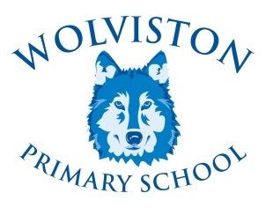

**Rights Respecting Schools Newsletter**

March

2019

**The Rights Respecting School Newsletter**

**(RRSA)**

The Pupils, Staff and Governors are continuing our Rights Respecting work ensuring that it is embedded in the ethos of our school.

As a level 2 school, we are to be reassessed in July to achieve Gold (level 2 equivalent). We are working very hard to achieve this!



**What is the award?**

In 1999 the world made a set of promises to children when it adopted ‘The Convention on the Rights of the Child’ CRC. The CRC is a major milestone in the effort to achieve a world fit for all children. The Unicef website is useful should you wish to explore this award further. *Everyone* at Wolviston Primary School is committed to the Rights Respecting School Award and believes it is making a positive difference to our children.

We want every child to realise they have rights as well as responsibilities towards each other and to understand how their own behaviour and actions can affect others. We also want to prepare all children for their journey into the world outside of our school so that they become good global citizens who can make a positive contribution.



**Rights Respecting Champions**

This term we are going from strength to strength by working with the Rights Respecting Champions who work closely with School Council and Team Green to embed rights and also launch the Global Goals.

Meetings are held fortnightly and the children are very passionate about bringing new ideas to our school.



**What’s next?**

The children are currently developing campaigning and exploring responsible consumption with school. We are working with Team Green to contact out local council to assist with resources and information to improve recycling in school. Look out for updates about our Rights Respecting work on our website and twitter page.

**Time to spare?**

If you would like to become part of our Steering group meetings and help with our journey to Gold, please pop into school and see Mrs Allred. It would be lovely to have parental views and opinions as part of our meetings.

