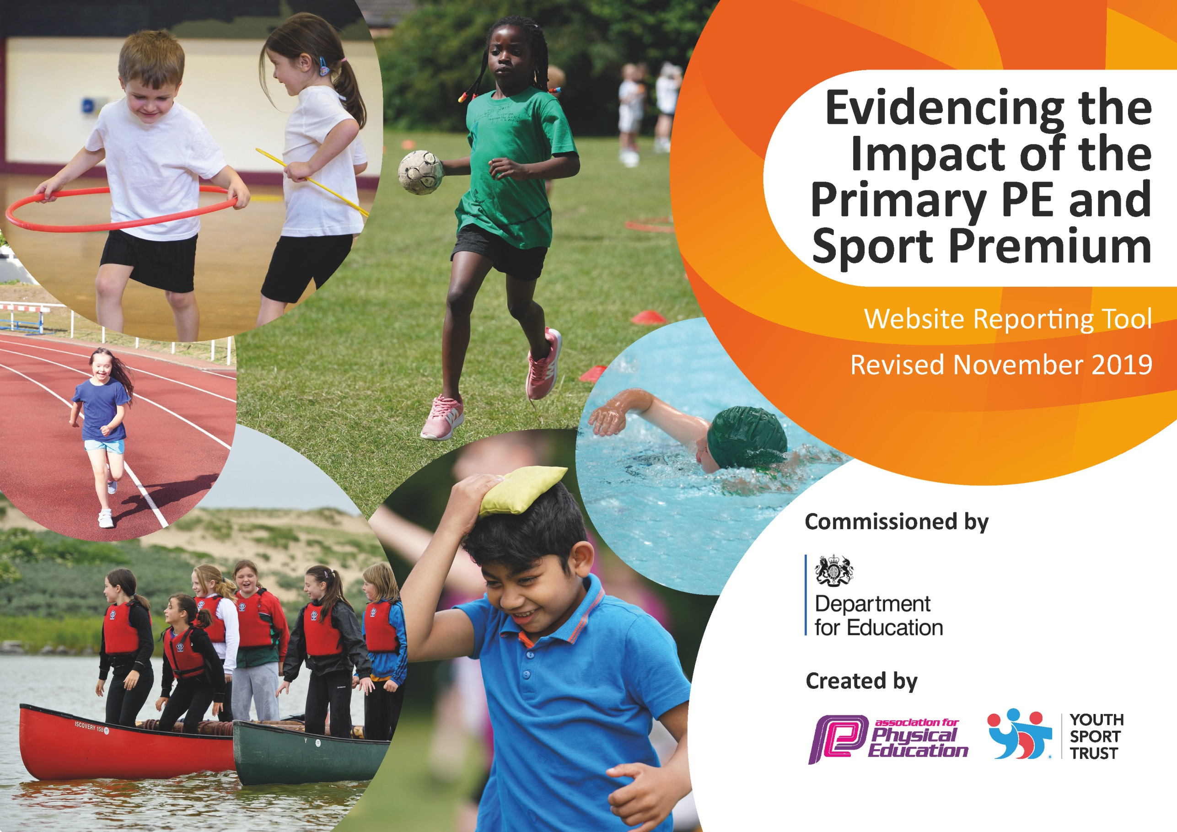
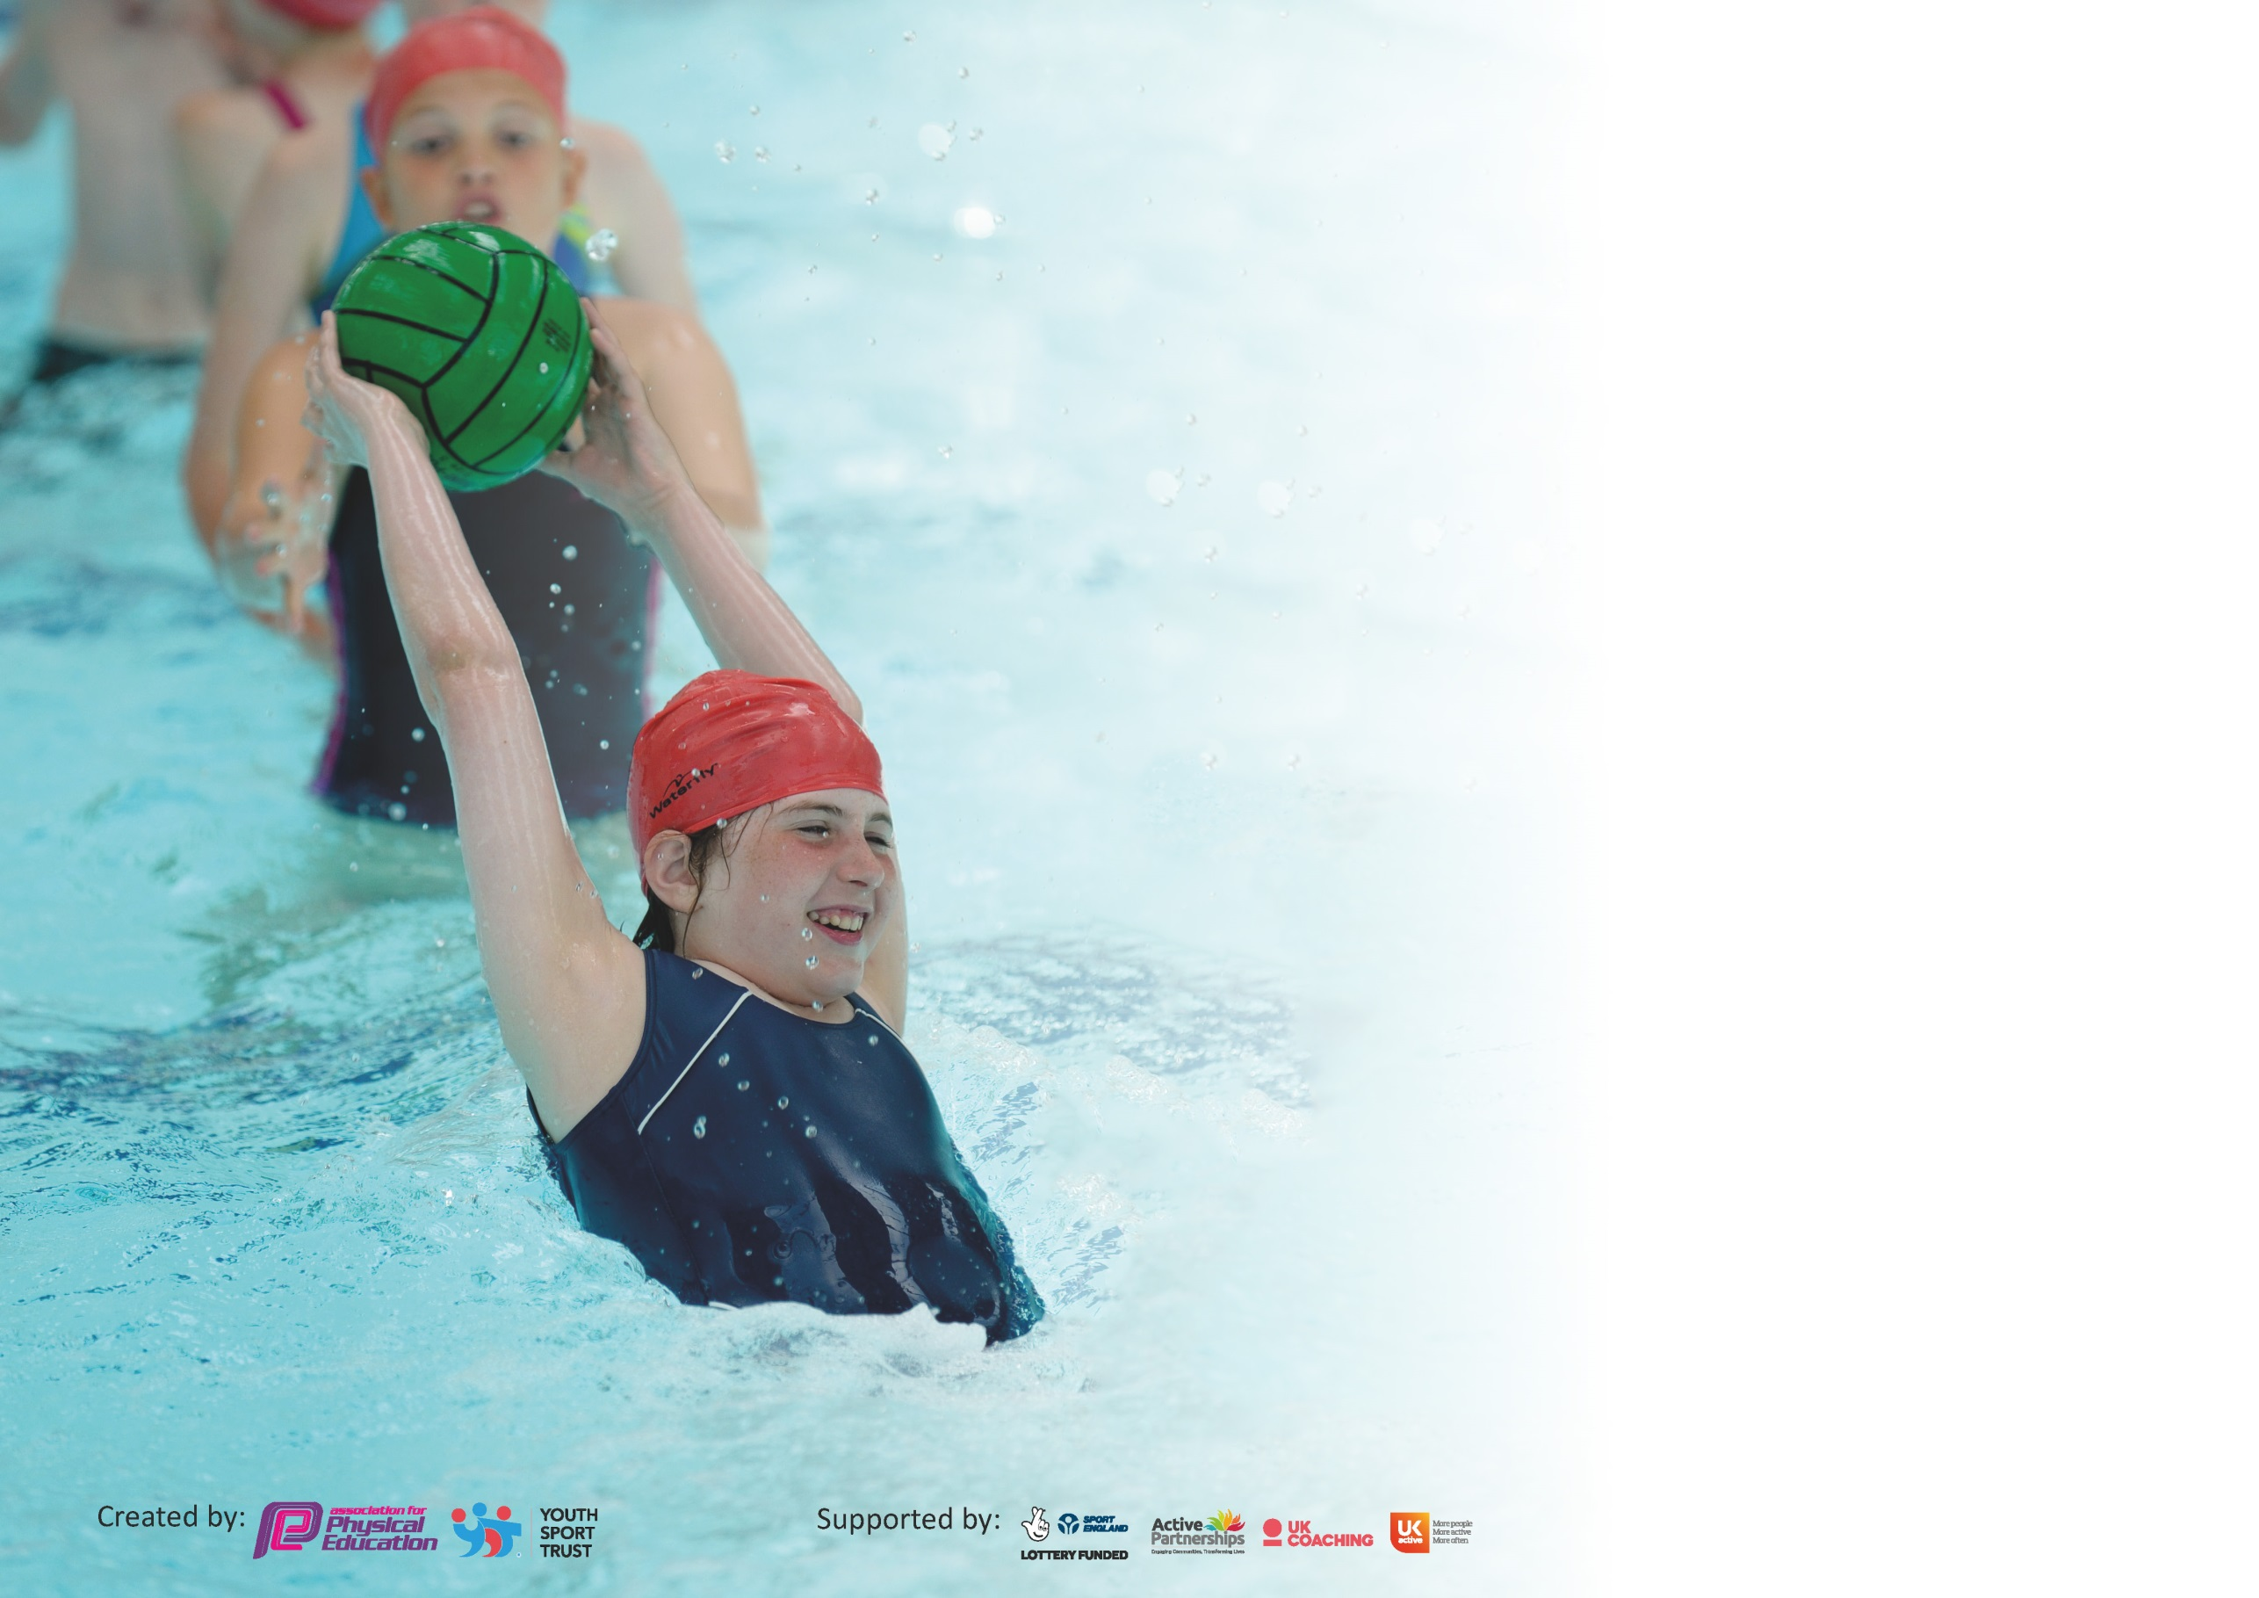

It is important that your grant is used effectively and based on school need. The Education Inspection Framework (Ofsted 2019 p64) makes clear there will be a focus on ‘whether leaders and those responsible for governors all understand their respective roles and perform these in a way that enhances the effectiveness of the school’.

Under the Quality of Education criteria (p41) inspectors consider the extent to which schools can articulate their curriculum (INTENT), construct their curriculum (IMPLEMENTATION) and demonstrate the outcomes which result (IMPACT).

To assist schools with common transferable language this template has been developed to utilise the same three headings which should make your plans easily transferable between working documents.

Schools must use the funding to make additional and sustainable improvements to the quality of Physical Education, School Sport and Physical Activity (PESSPA) they offer. This means that you should
use the Primary PE and Sport Premium to:

- Develop or add to the PESSPA activities that your school already offer
- Build capacity and capability within the school to ensure that improvements made now will benefit pupils joining the school in future years

Please visit gov.uk for the revised DfE guidance including the 5 key indicators across which schools should demonstrate an improvement. This document will help you to review your provision and to report your spend. DfE encourages schools to use this template as an effective way of meeting the reporting requirements of the Primary PE and Sport Premium.

We recommend you start by reflecting on the impact of current provision and reviewing the previous spend.

Schools are required to publish details of how they spend this funding as well as on the impact it has on pupils’ PE and sport participation and attainment by the end of the summer term or by 31st July 2020 at the latest.

We recommend regularly updating the table and publishing it on your website throughout the year. This evidences your ongoing self-evaluation of how you are using the funding to secure maximum, sustainable impact. Final copy must be posted on your website by the end of the academic year and no later than the 31st July 2020. To see an example of how to complete the table please click HERE.

Support for review and reflection - considering the 5 key indicators from DfE, what development needs are a priority for your setting and your pupils now and why? Use the space below to reflect on previous spend and key achievements and areas for development.

Key achievements to date until July 2019: | Areas for further improvement and baseline evidence of need:
All children from Key Stage 1 and Key Stage 2 given the opportunity to represent the school at local cluster competitions and festivals.  A and B teams sent to all competitions for Year 5 and 6 children.  Increased number of previously inactive children (not previously attending clubs) now attending active extra-curricular clubs. | Evaluate effectiveness of PE curriculum, how it will be taught, any additional training or resources that will be required to support the delivery of high-quality PE.  Identify inactive children in current cohort and opportunities for them to attend active extra-curricular clubs.

Meeting national curriculum requirements for swimming and water safety.
What percentage of your current Year 6 cohort swim competently, confidently and proficiently over a distance of at least 25 metres?  N.B. Even though your pupils may swim in another year please report on their attainment on leaving  primary school at the end of the summer term 2020. | 68%
What percentage of your current Year 6 cohort use a range of strokes effectively [for example, front crawl, backstroke and breaststroke]? | 68%
What percentage of your current Year 6 cohort perform safe self-rescue in different water-based situations? | 89.5%
Schools can choose to use the Primary PE and Sport Premium to provide additional provision for swimming but this must be for activity over and above the national curriculum requirements. Have you used it in this way? | Yes/No

Action Plan and Budget Tracking
Capture your intended annual spend against the 5 key indicators. Clarify the success criteria and evidence of impact that you intend to measure to evaluate for pupils today and for the future.

Academic Year: 2019/20 | Total fund allocated: £16950 | Date Updated: July 2020
Key indicator 1: The engagement of all pupils in regular physical activity – Chief Medical Officer guidelines recommend that primary school pupils undertake at least 30 minutes of physical activity a day in school |  |  |  | Percentage of total allocation:
 |  |  |  | %
Intent | Implementation |  | Impact | 10.5%
Your school focus should be clear what you want the pupils to know and be able to do and about  what they need to learn and to  consolidate through practice: | Make sure your actions to achieve are linked to your intentions: | Funding allocated: | Evidence of impact: what do pupils now know and what can they now do? What has changed?: | Sustainability and suggested next steps:
- Encourage children to increase their physical activity levels throughout the school day.  Encourage active journeys to and from school  Encourage upper Key Stage 2 to cycle to school  Ensure all children develop the necessary skills for physical literacy | - Active playground equipment  Walk to school/Travel Tracker  Cycle and road awareness lessons for Class 4  Balance bikes to develop coordination in EYFS | £1029.35  £500  £243 | Children more active during break and lunch times, becoming more independent in organising active games.  More children taking active journeys to school.  Better balance and coordination evident throughout the day in EYFS. | Use Playground CREW to demonstrate how equipment could be used and how it should be stored. Playground ‘Coaches’ to set up activities for younger children.  Children start school with physical confidence and are able to access PE and sports in school.
Key indicator 2: The profile of PESSPA being raised across the school as a tool for whole school improvement |  |  |  | Percentage of total allocation:
 |  |  |  | %
Intent | Implementation |  | Impact | 3%
Your school focus should be clear what you want the pupils to know and be able to do and about  what they need to learn and to  consolidate through practice: | Make sure your actions to achieve are linked to your intentions: | Funding allocated: | Evidence of impact: what do pupils now know and what can they now do? What has changed?: | Sustainability and suggested next steps:
Children to develop their leadership skills  Increase awareness of being active throughout school  Children to be proud to represent their school | Sports Crew and Playground CREW meet regularly to organise activities and sports in school.  Certificates, awards and stickers for achievements.  New football kit  Replacement kit for sporting events | £500

Key indicator 3: Increased confidence, knowledge and skills of all staff in teaching PE and sport |  |  |  | Percentage of total allocation:
 |  |  |  | %
Intent | Implementation |  | Impact | 51%
Your school focus should be clear | Make sure your actions to | Funding | Evidence of impact: what do | Sustainability and suggested
what you want the pupils to know | achieve are linked to your | allocated: | pupils now know and what | next steps:
and be able to do and about | intentions: |  | can they now do? What has
what they need to learn and to |  |  | changed?:
consolidate through practice:
Ensure staff are trained by accessing CPD training courses.  All children learn and improve their skills through consistently high-quality PE lessons. | Ensure staff are sent on relevant CPD training.  Youth Sport Trust Membership  PE Coordinator to work alongside PE staff in order to lead staff effectively and impact on the standard of teaching and learning in PE.  Review PE curriculum and plans. | £500  £200  £8000 | CPD attended and put into practise.  Raised the level of PE across the school. Reviewed PE curriculum ensuring all children access more during lessons. Clear improvement in core skills throughout the school. | PE Coordinator to make use of resources from CPD and share with staff.  Staff with greater understanding of delivering PE lessons and differentiation to support all abilities.
Key indicator 4: Broader experience of a range of sports and activities offered to all pupils |  |  |  | Percentage of total allocation:
 |  |  |  | %
Intent | Implementation |  | Impact | 9%
Your school focus should be clear | Make sure your actions to | Funding | Evidence of impact: what do | Sustainability and suggested
what you want the pupils to know | achieve are linked to your | allocated: | pupils now know and what | next steps:
and be able to do and about | intentions: |  | can they now do? What has
what they need to learn and to |  |  | changed?:
consolidate through practice:
Specialist coaches to work with children allowing them to experience a wide range of sports and activities.  Maintain equipment to support PE, games and other activities  Additional achievements: | Arrange for specialist coaches to deliver extra-curricular clubs and taster days. | £600*  £929.27 | Events rearranged due to cancellation of Sports Week due to COVID-19  Children able to be active for more of the PE lesson, reduced sharing of equipment. | Greater endurance and attitude towards PE.

Key indicator 5: Increased participation in competitive sport |  |  |  | Percentage of total allocation:
 |  |  |  | %
Intent | Implementation |  | Impact | 22.5%
Your school focus should be clear | Make sure your actions to | Funding | Evidence of impact: what do | Sustainability and suggested
what you want the pupils to know | achieve are linked to your | allocated: | pupils now know and what | next steps:
and be able to do and about | intentions: |  | can they now do? What has
what they need to learn and to |  |  | changed?:
consolidate through practice:
Participate in a range of competitions and festivals organised by Stockton SSP. | Stockton School Sports Partnership membership.  Send A and B teams to sporting competitions and festivals.  Entry to external competitions  Transport to competitions  Equipment to prepare for competitions | £1695  £200  £1000  £930 | All children in school attending festivals or competitions (from reception to year 6). Competitions from a wide range of sports with children representing the school at Stockton and Tees Valley finals.  Increased competence and confidence when attending competitions. | Continue to encourage children’s participation in competitions and festivals.  Equipment to be stored safely to ensure it is available each year.

Signed off by
Head Teacher:
Date:
Subject Leader: | - Wilcox
Date: | 16.7.2020
Governor:
Date:

